***Log onto DataStage Designer***

1. Double-click on the DataStage Designer Client icon on the Windows desktop.

2. Type information to log into your DataStage project using the dsuser ID.

3. Click OK.

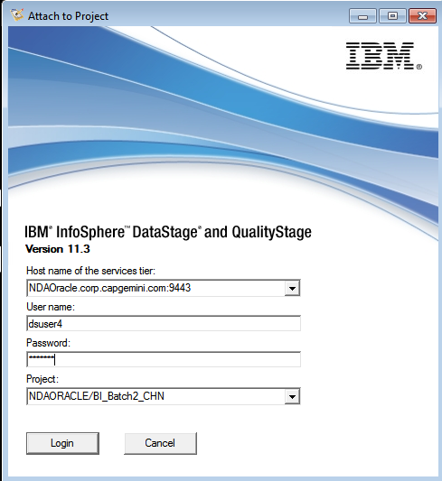

***Create a Repository folder***

1. Select your project folder in the Repository, click your right mouse button, and then click New>Folder. Create a folder named “UshaPravallika_161683”. Under it, create two folders: Jobs and Metadata.

2. Click Repository>Refresh to refresh the Repository (which moves the folder you created to the top).

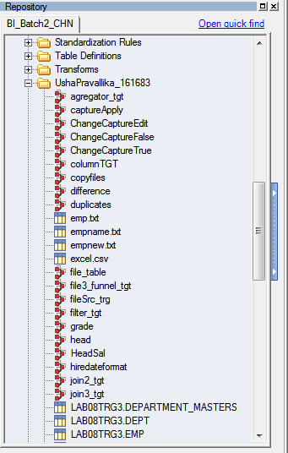

***Import DataStage component files***

1. Click Import>DataStage Components.

2. In the Import from file box, select the TableDefs.dsx file in your ISFiles>DsxFiles directory on your client machine.

3. Select the Import selected button.

4. Click OK.

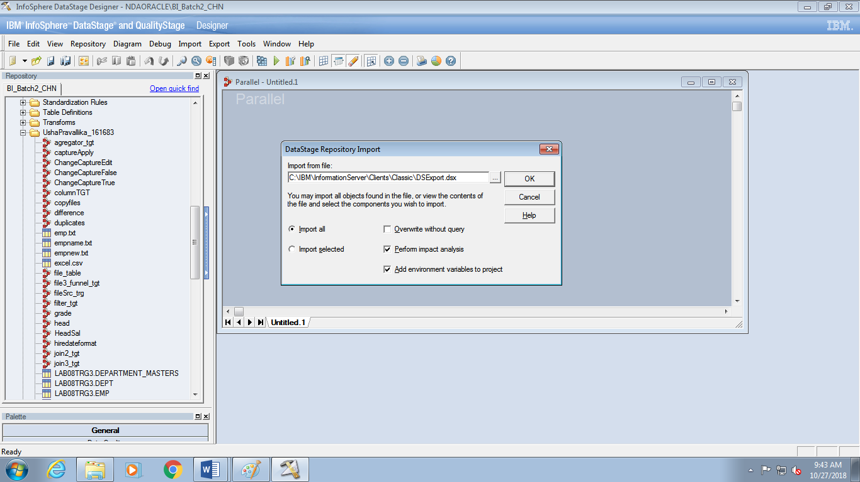

5. Select the table definition and then click OK.

6. Open up the table definition you’ve imported and examine it. You will find it in the UshaPravallika_161683>Metadata folder.

• On the General tab, note the Data source type, Data source name, and Table/file

name.

• Note the column definitions and their types on the Columns tab.

***Backup your project***

In this task, you backup (export) your UshaPravallika_161683 folder into a file named Training.dsx.

1. Select your _Training folder, click your right mouse button, and then click Export.

2. In the Export to file box, select your D:\usha\Module2\Datastage\ClassBook\training.dsx folder and specify a file name Training.dsx.

3. Click Export.

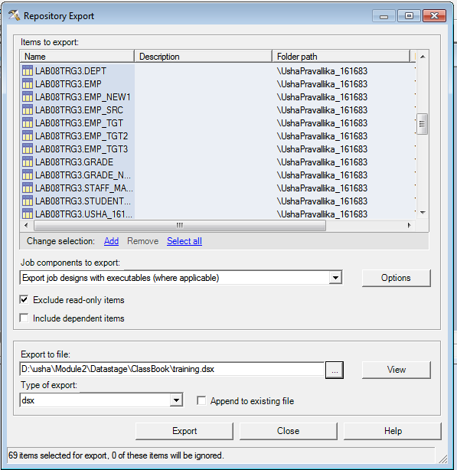

***: Import a table definition from a sequential file***

1. In a text editor, open up theemp.txt file in your sequential file directory and examine its format and contents. Some questions to consider:

• Is the first row column names?

• Are the columns delimited or fixed-width?

• How many columns? What types are they?

2. In Designer, click Import>Table Definitions>Sequential File Definitions.

3. Select your usha_pravallika directory.

4. Specify UshaPravallika_161683 as the “To category”.

5. Select your emp.txt file.

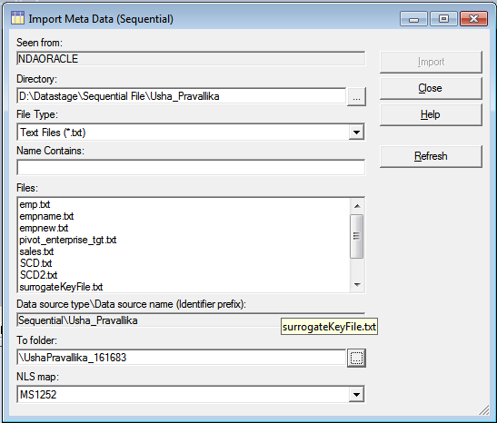

6. Click Import.

7. Specify the general format on the Format tab. Be sure to specify that the first line is

column names, if this is the case. Then Data Stage can use these names in the column definitions.

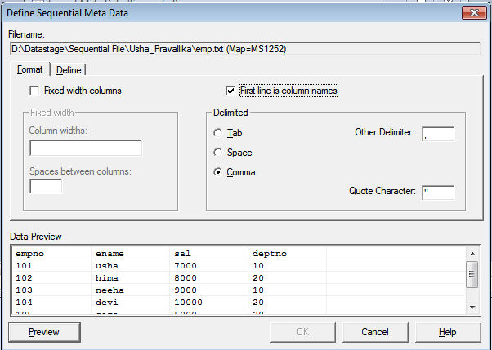

8. Click Preview to view the data in your file in the specified format. This is a check

whether you have defined the format correctly. If it looks like a mess, you haven’t

correctly specified the format.

9. Click the Define tab to examine the column definitions.

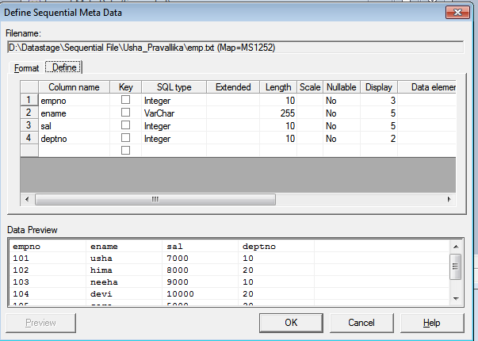

10. Click OK, to import your table definition.

11. After closing the import window, locate and examine your new table definition in the

Repository window

**Lab 2:**

***Create a two-node configuration file***

The lab exercises that follow in this and later modules are more instructive when the jobs are run

using a two-node (or more) configuration file. Configuration files are discussed in more detail in

a later module.

1. Click Tools>Configurations.

2. In the Configurations box, select the default configuration.

3. If only one node is listed, make a copy of node through the curly braces and change the

name of the node to “node2”. When done, your file should now look like this:

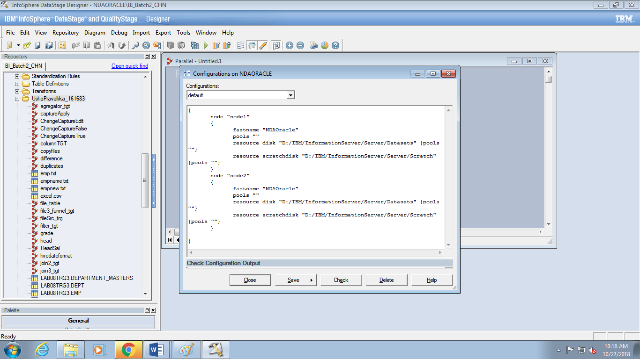

4. Save and close.

***Create a parallel job***

1. Open a new Parallel job and save it under the name rowgeneratorTgt. Save it your

UshaPravallika_161683>Jobs folder.

2. Add a Row Generator stage and a Peek stage.

3. Draw a link from the Row Generator stage to the Peek stage. Change the names of the

stages and links as shown.

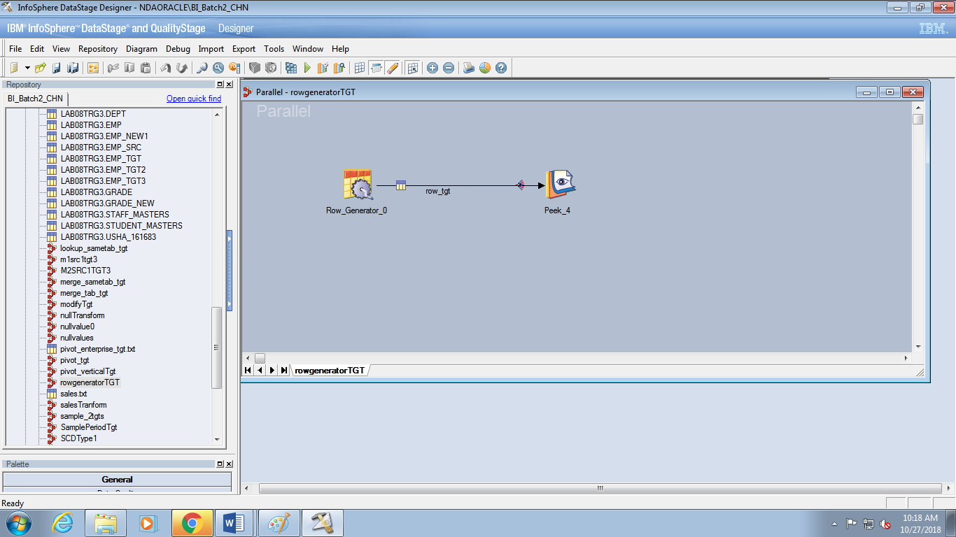

4. Open up the Row Generator stage to the Columns tab. Click the Load button to load the

column definitions from the Employees Table definition you imported in an earlier lab.

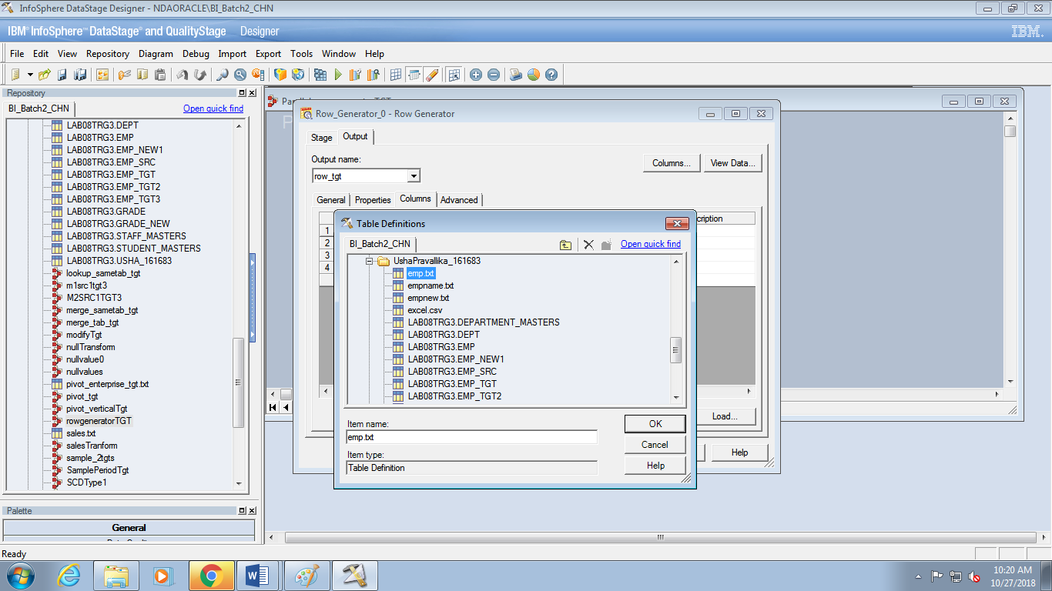

5. Verify your column definitions with the following.

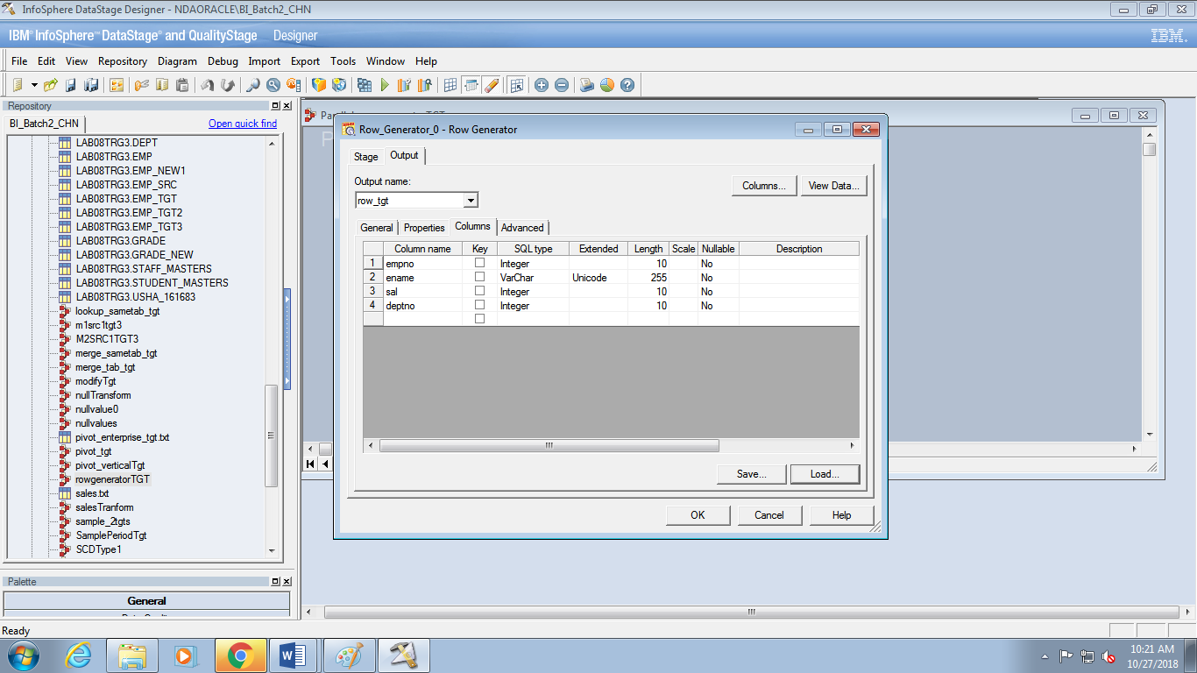

6. On the Properties tab specify the 100 rows are to be generated.

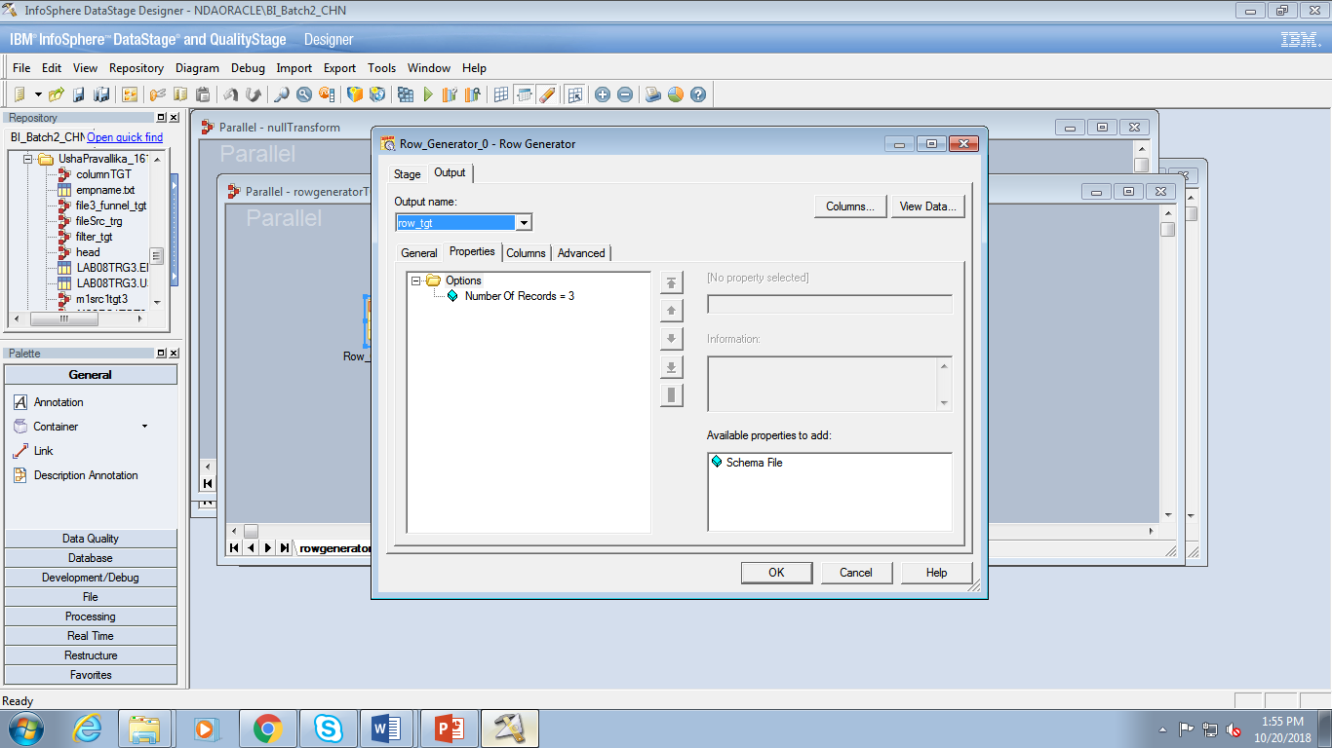

7. Click View Data to view the data that will be generated.

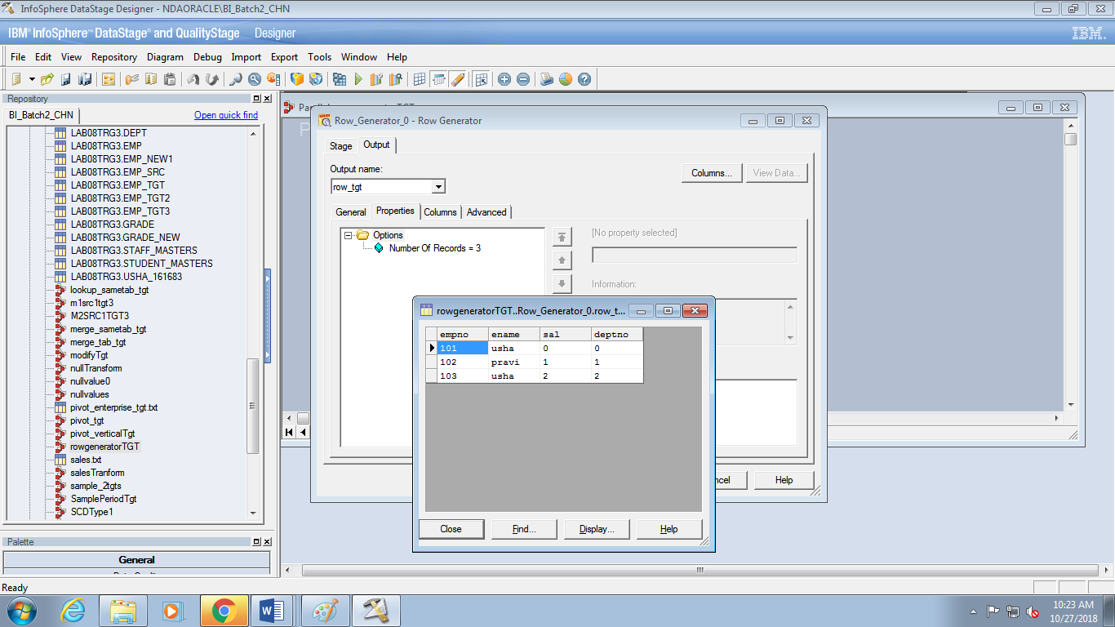

***Compile, run, and monitor the job***

1. Compile your job.

2. Click your right mouse button over an empty part of the canvas. Select or verify that

“Show performance statistics” is enabled.

3. Run your job.

4. Move to Director from within Designer by clicking Tools>Run Director.

5. In the Director Status window select your job.

6. Move to the job log.

7. Scroll through the messages in the log. There should be no warnings (yellow) or errors

(red). If there are, double-click on the messages to examine their contents. Fix the problem and then recompile and run.

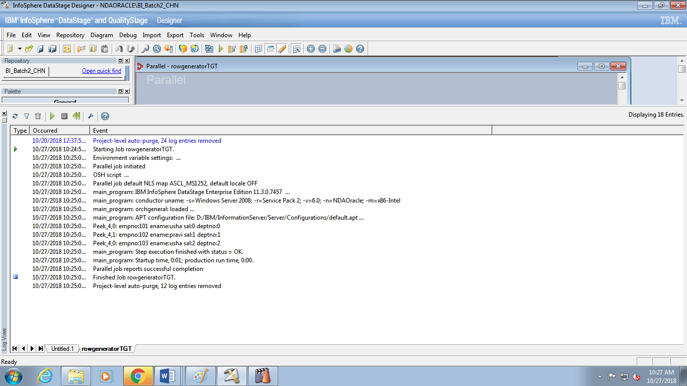8. Notice that there are one or more log messages starting with “PeekEmployees,” the label

on your Peek stage. Double click on one of these to open the message window.

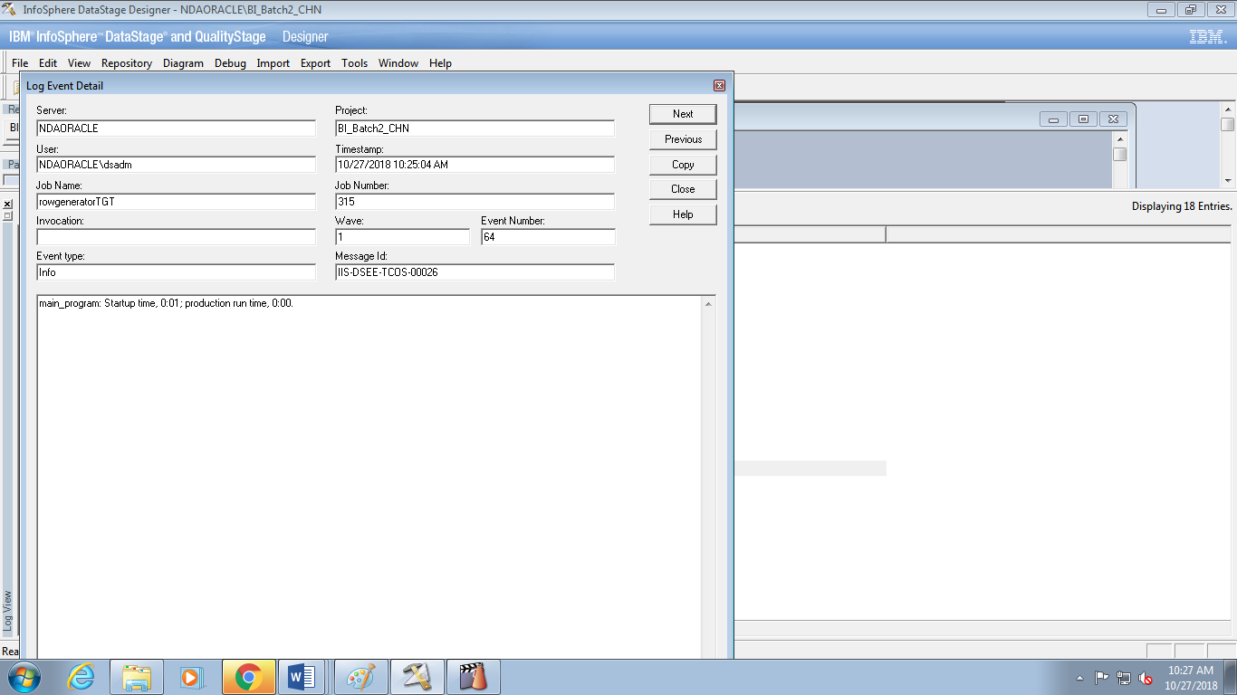

***TASK: Specify Extended Properties***

1. Save your job as rowgeneratorTgt in your UshaPravallika_161683>Jobs folder.

2. Open up the Row Generator stage to the Columns tab. Double-click on the row numberto the left of the first column name.

3. Specify the Extended Properties as shown.

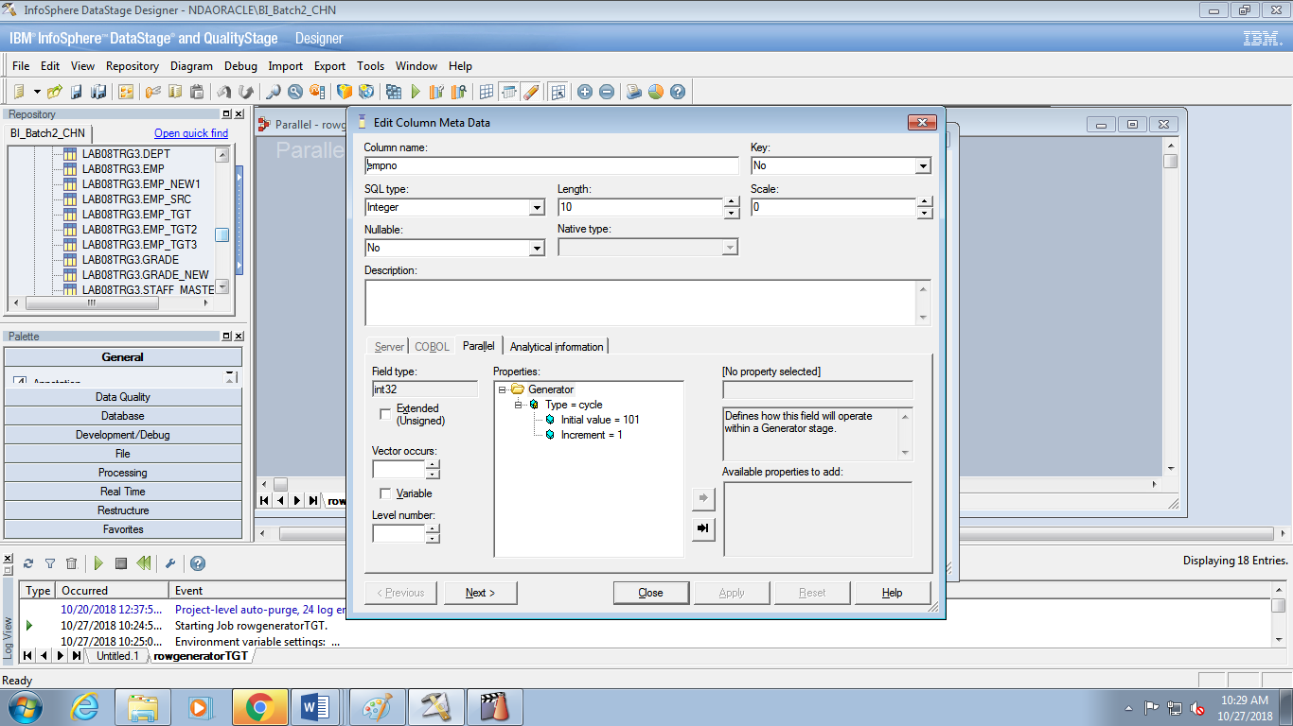

4. For the Name column specify that you want to cycle through 3 names, your choice.

6. Click View data to see the data that will be generated.

***TASK: Document your job***

1. Add an Annotation stage to your job diagram that describes what your job does. Open up

the Annotation stage and choose another background color.

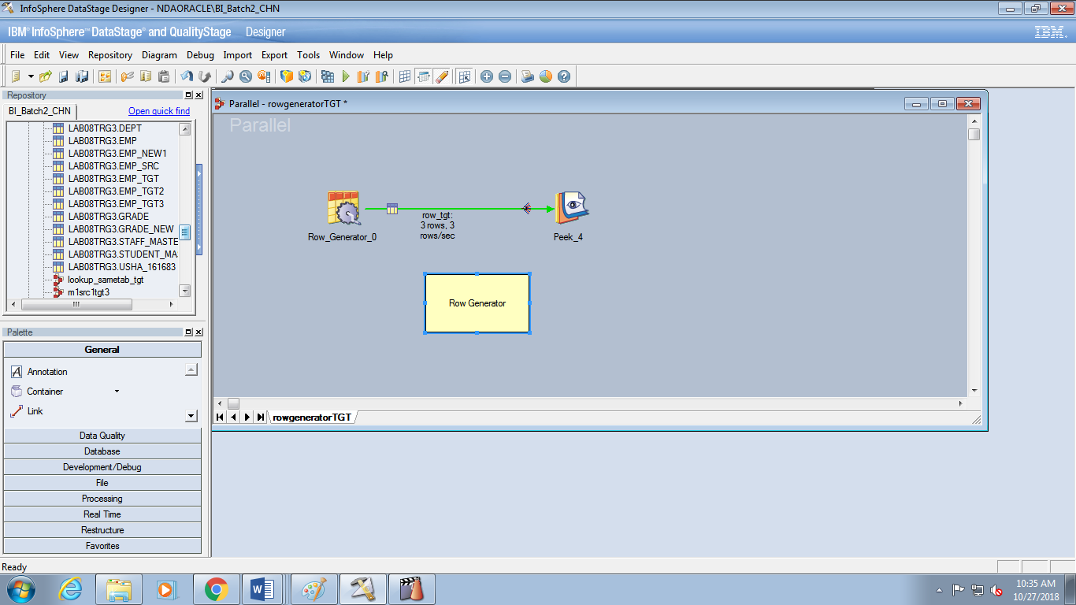

2. In the Job Properties window, short description, also briefly describe what your job does.

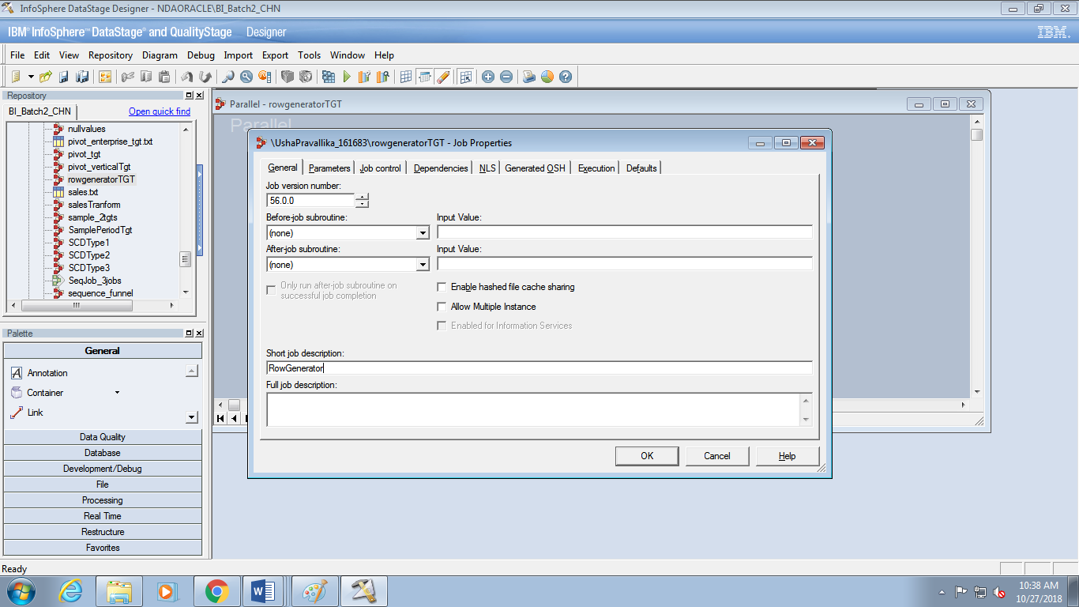

3. Compile and run your job. View the messages in the Director log. Fix any warnings or

errors.

4. Verify the data by examining the Peek stage messages in the log.

***Task: Add a job parameter***

1. Save your job as rowgeneratorTgt in your UshaPravallika_161683>Jobs folder.

2. Open up the Job Properties window. Click on the Parameters tab.

3. Define a new parameter named NumRows with a default value of 10. Its type is Integer.

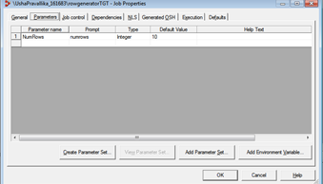

4. Open up the Properties tab of the RowGenerator stage in your job. Use your NumRows

job parameter to specify the number of rows to generate

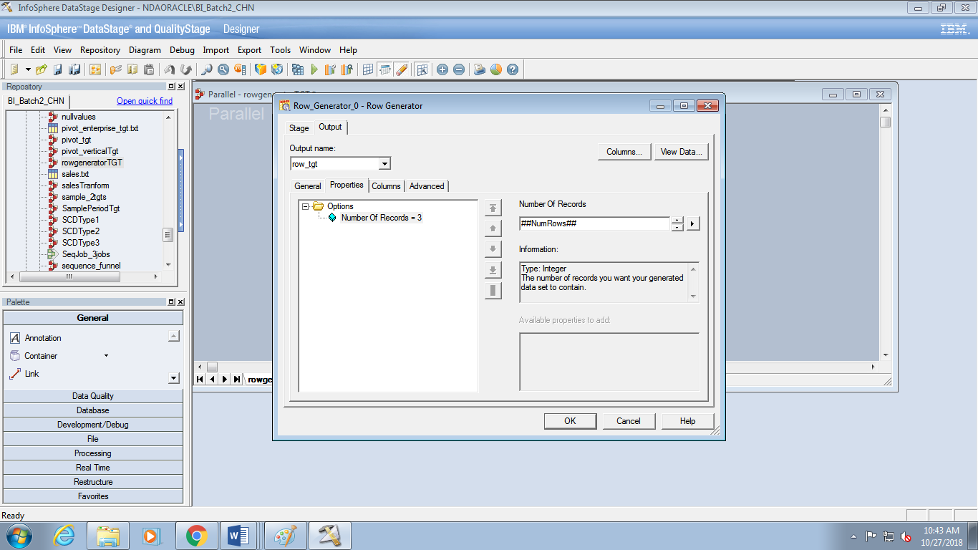

5. View the data.

6. Compile and run your job. Verify the results.

***Task: Backup your project***

1. Select your UshaPravallika_161683 folder.

2. Export the contents of your folder to your Training.dsx file

**LAB:3**

***Task: Read and write to a sequential file***

1. Open a new Parallel job and save it under the name CreateSeqJob. Save it into your

ushapravallika_161683>Jobs folder.

2. Add a Sequential stage, a Copy stage, and a second Sequential stage. Draw links. Name

the stages and links as shown.

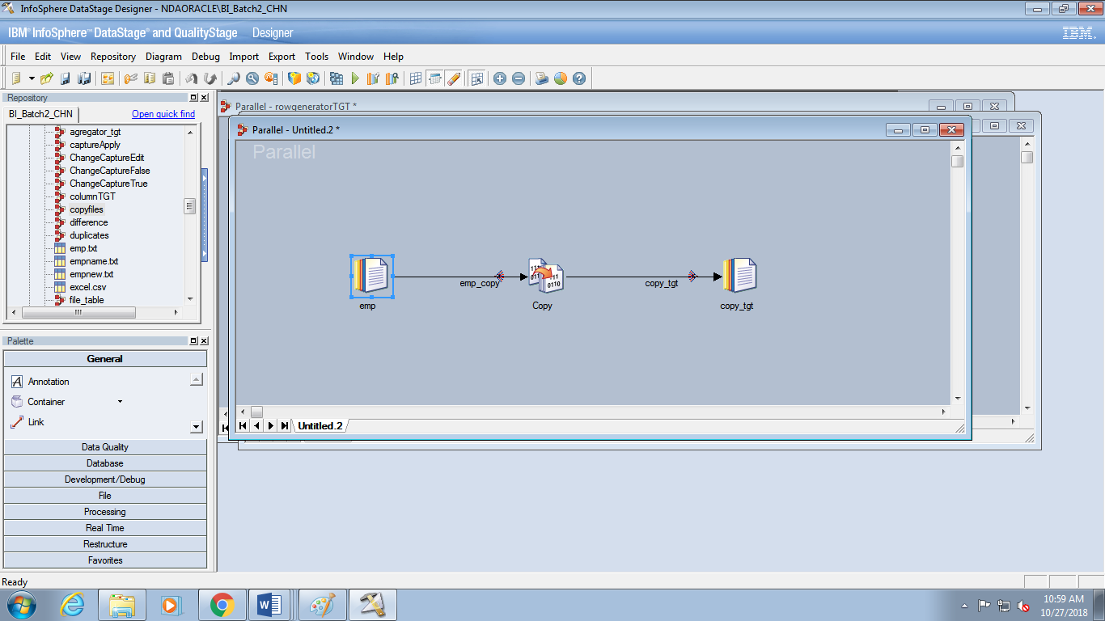3. In the Sequential source stage Columns and Format tabs, load the format and column

definitions from the emp.txt table definition you imported in a

previous exercise.

4. On the Properties tab specify the file to read and other relevant properties. Here be sure

to set the First Line is Column Names to True. If you don’t your job will have trouble

reading the first row and issue a warning message in the Director log.

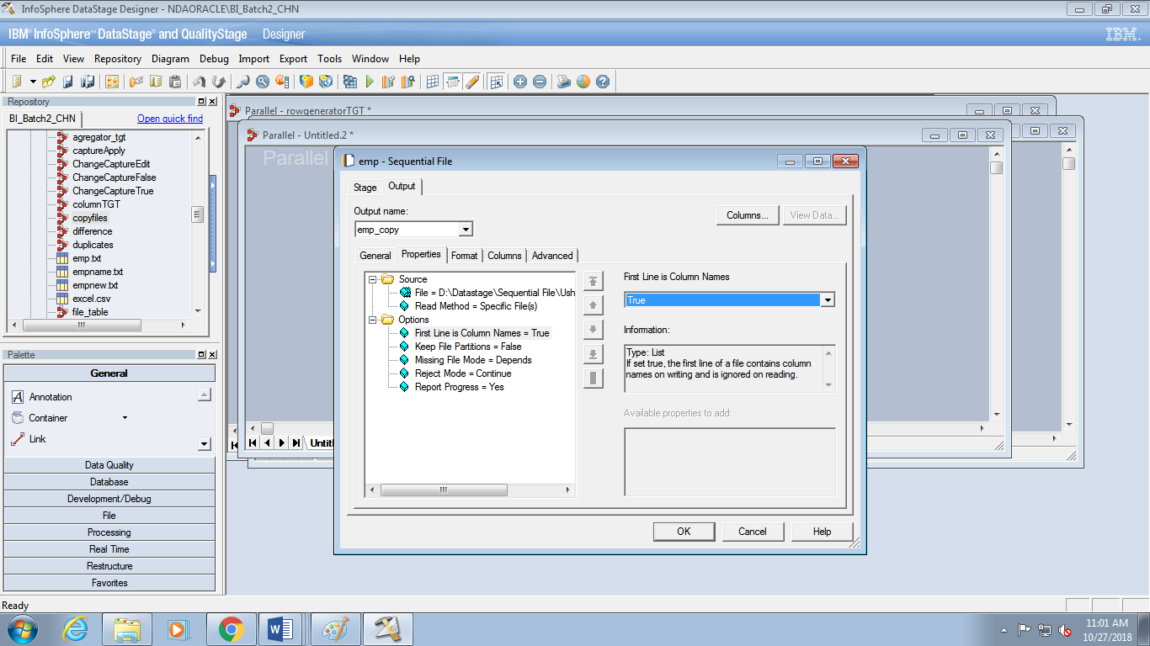

5. Click View data to view the data to verify that the metadata has been specified properly.

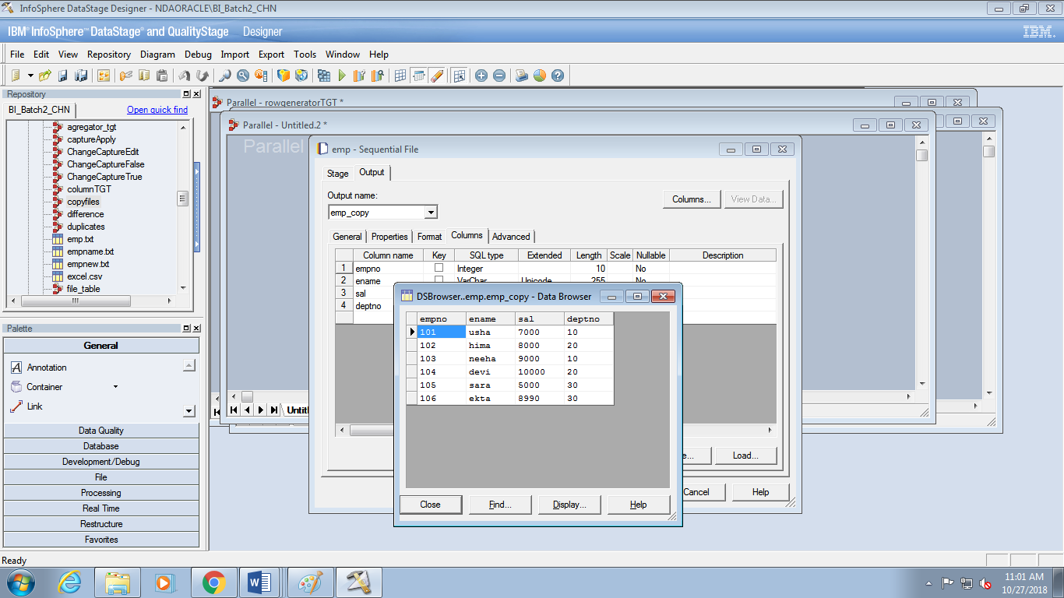

6. In the Copy stage Output>Mapping tab, drag the columns across from the source to the

target.

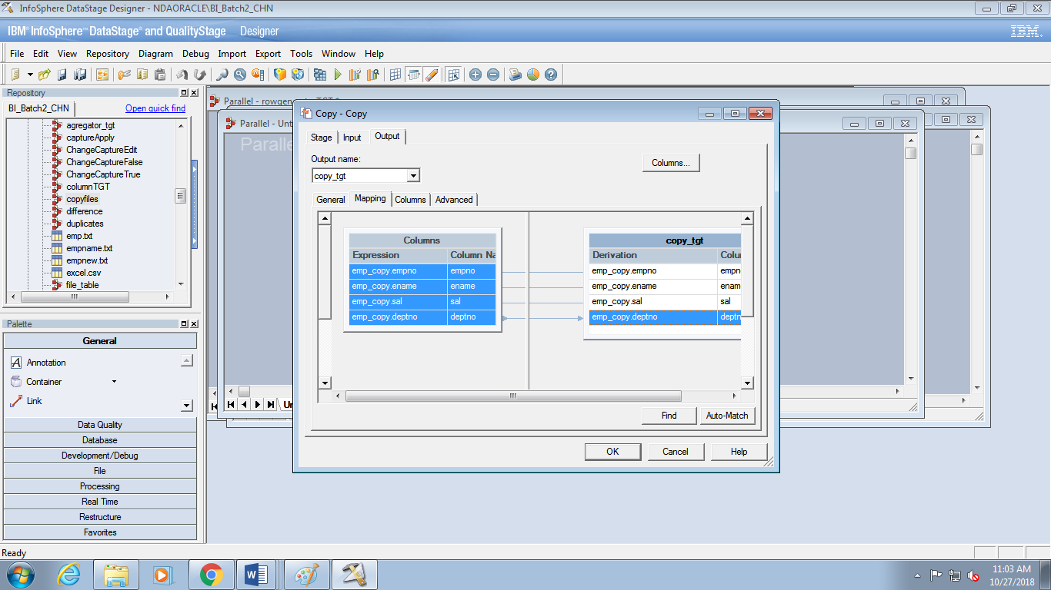

7. In the target Sequential stage, create a delimited file with the comma as the delimiter.

Name the file the Selling_Group_Mapping_Copy.txt and write to your ISFiles>Temp

directory. Create it with a first line of column names. It should overwrite any existing

file with the same name.

8. Compile and run your job.

9. In Director, view the job log. Fix any errors

***Create and use a job parameter***

1. Save your CreateSeqJob job as CreateJobParam. Rename the last link and Sequential

File stage to “TargetFile”.



2. Open up the job properties window.

3. On the parameters tab, define a job parameter named TargetFile of type string. Create an

appropriate default filename, e.g., TargetFile.txt.

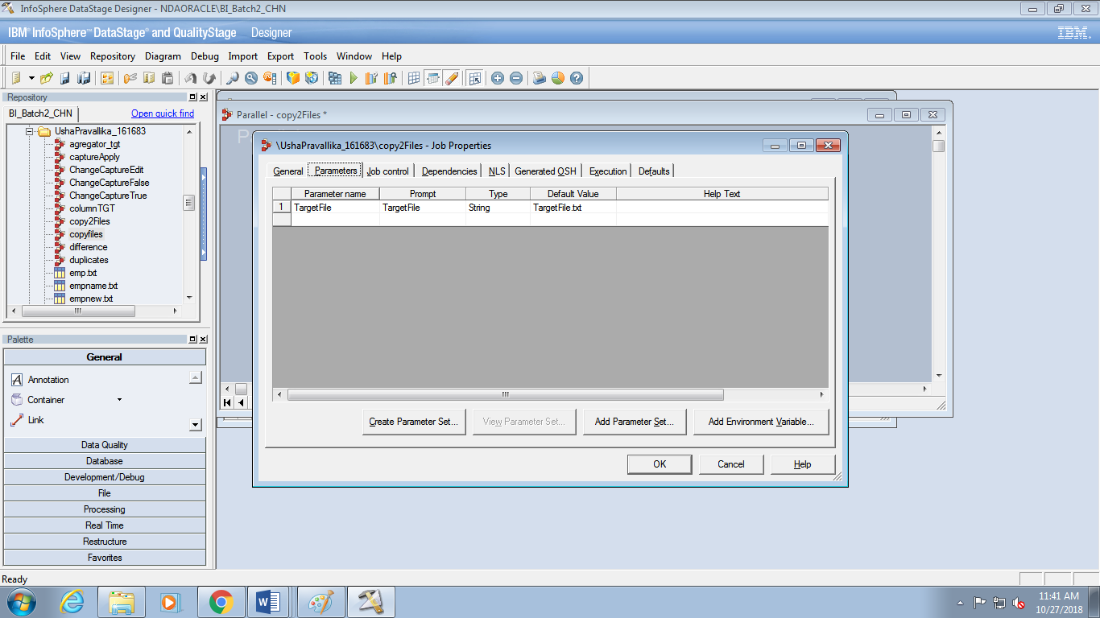

4. Open up your target stage to the Properties tab. Select the File Property. In the File text

box, replace the name of your file by your job parameter. Retain the rest of your file

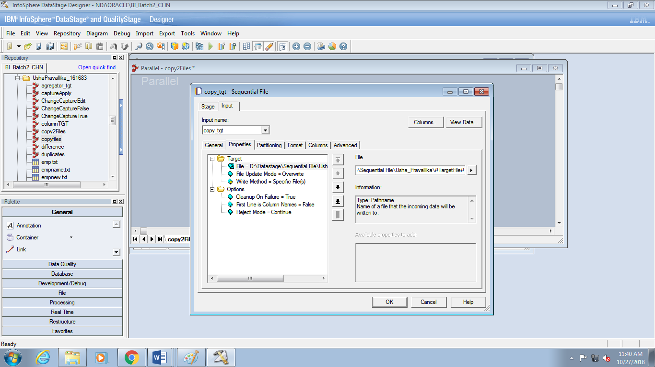

***Add Reject links***

1. Add a second link (which will automatically become a reject link) from the source

Sequential File stage to a Peek stage. Also add an output link from the target Sequential

File stage to a Peek stage. Give appropriate names to these new stages and links.

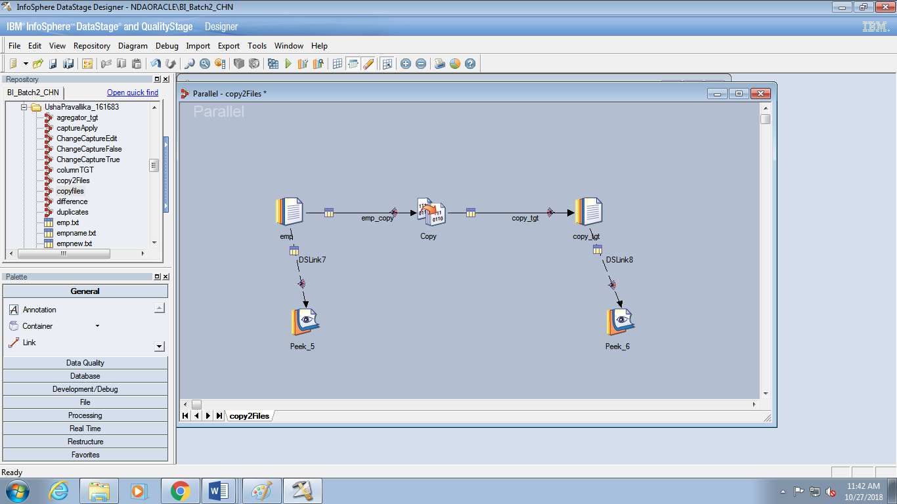

2. On the Properties tab of each Sequential File stage, change the Reject Mode property

value to “Output”.

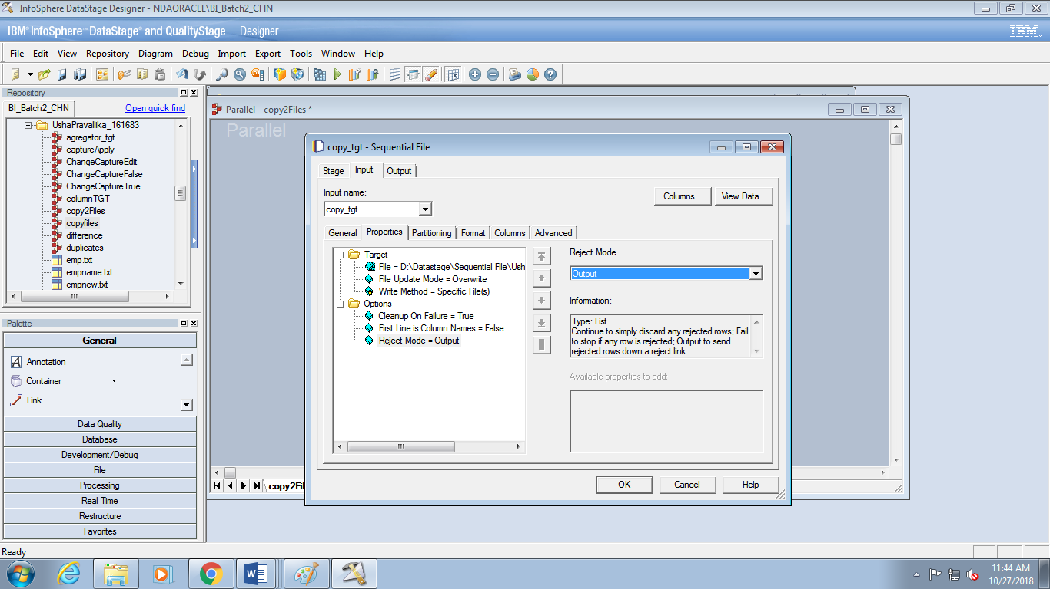

3. Compile and run. Verify that it’s running correctly. You shouldn’t have any rejects or

errors or warnings.

4. To test the rejects link, temporarily change the property First Line is Column Names to

False in the Source stage and then recompile and run. This will cause the first row to be

rejected because the values in the first row, which are all strings, won’t fit the column

definitions, some of which are integers.

5. Examine the DataStage log. What row shows up in the Peek message? Examine the

warning messages before the Peek. Note the number of rows that are successfully

imported and how many are rejected.

***Read a file using multiple readers***

1. Save your job as CreateSeqJobMultiRead.

2. Click the Properties tab of your source stage.

3. Click the Options folder and add the “Number of Readers Per Node” property. Set this

property to 2.

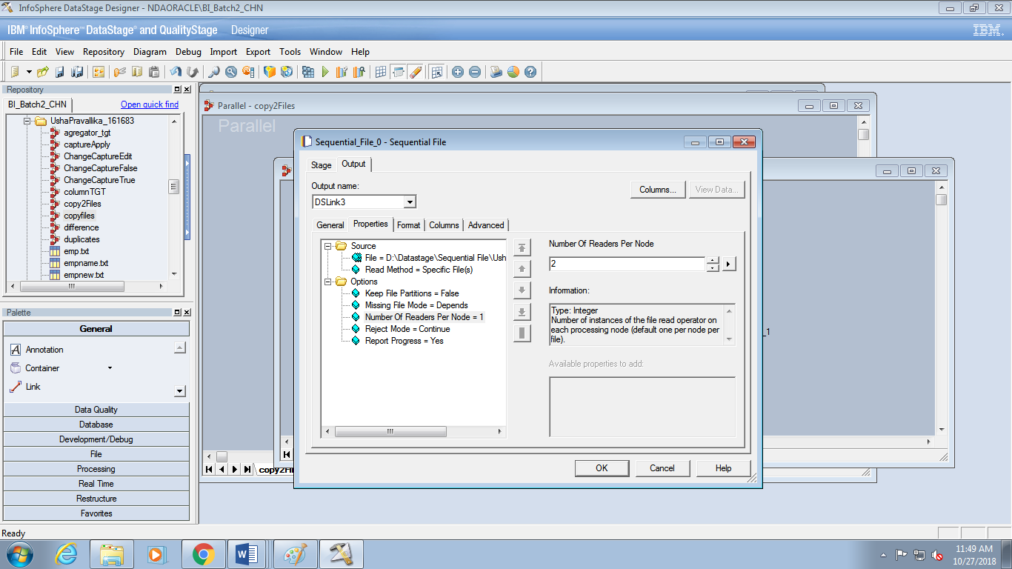

4. Compile and run your job.

5. View the job log.

***Create job reading multiple files***

1. Save your job as CreateSeqJobPattern.

2. Run your job twice specifying the following file names in the job parameter for the target

file: OutFileA.txt, OutFileB.txt.

3. Edit the source Sequential stage:

• Change read method to File Pattern

• Place a wildcard (?) in the last portion of the file name:

OutFile?.txt

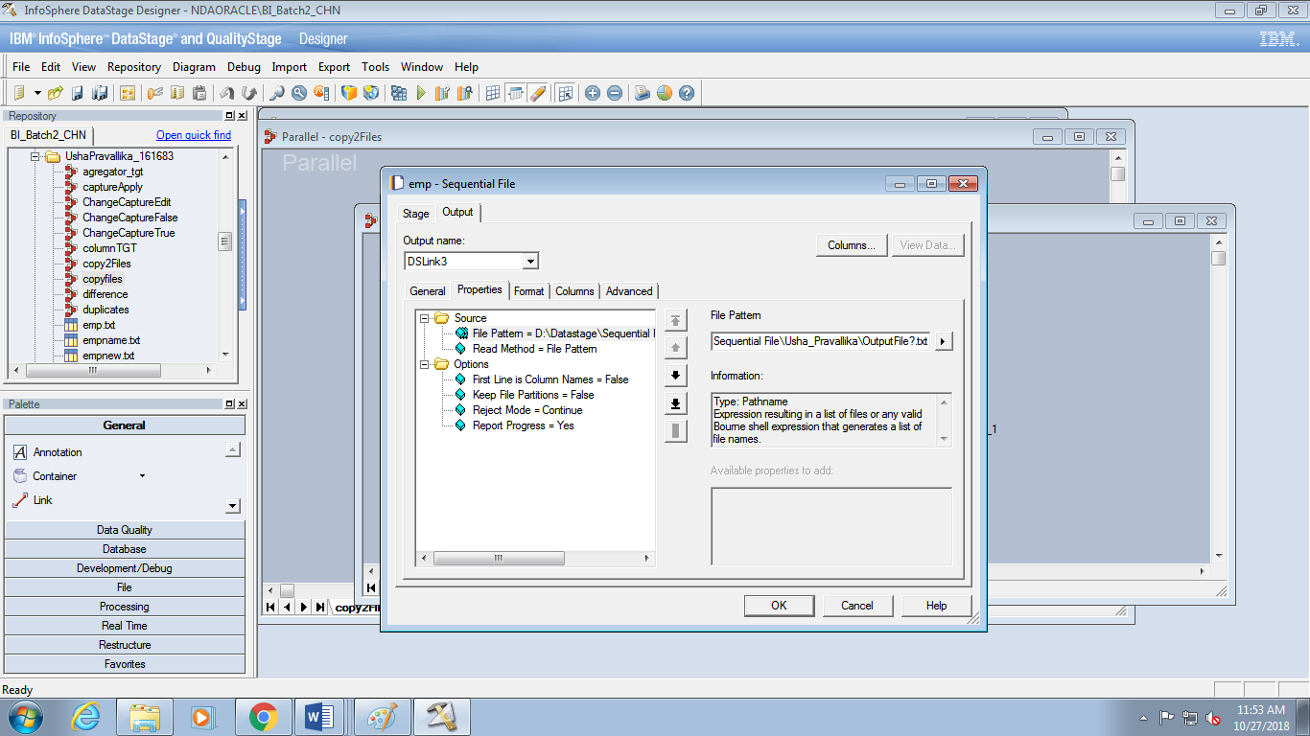

. Click View Data to verify that you can read the files.

5. Compile and run the job. View the job log.

6. Verify the results. There should be two copies of each row, since you are now reading

two identical files.

***Create a data set***

1. Open up your CreateSeqJob job and save it as CreateDataSetJob.

2. Delete the target sequential stage leaving a dangling link.

3. Add a DataSet stage and connect it to the dangling link. Change the name of the target

stage as shown

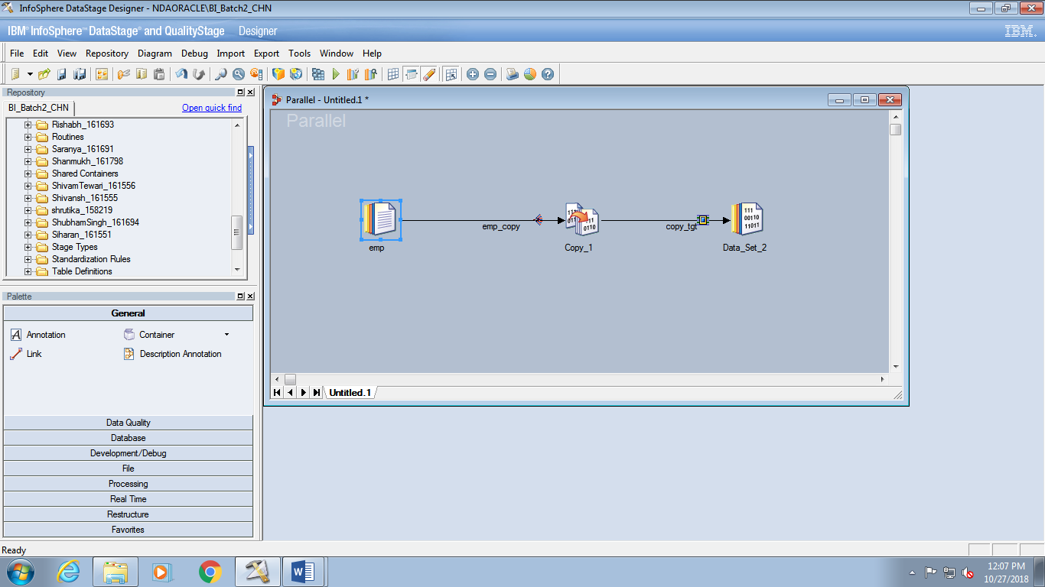

4. Edit the Data Set stage properties. Write to a file named emp_Mapping.ds in

your SequentialFiles>Usha_Pravallika directory.

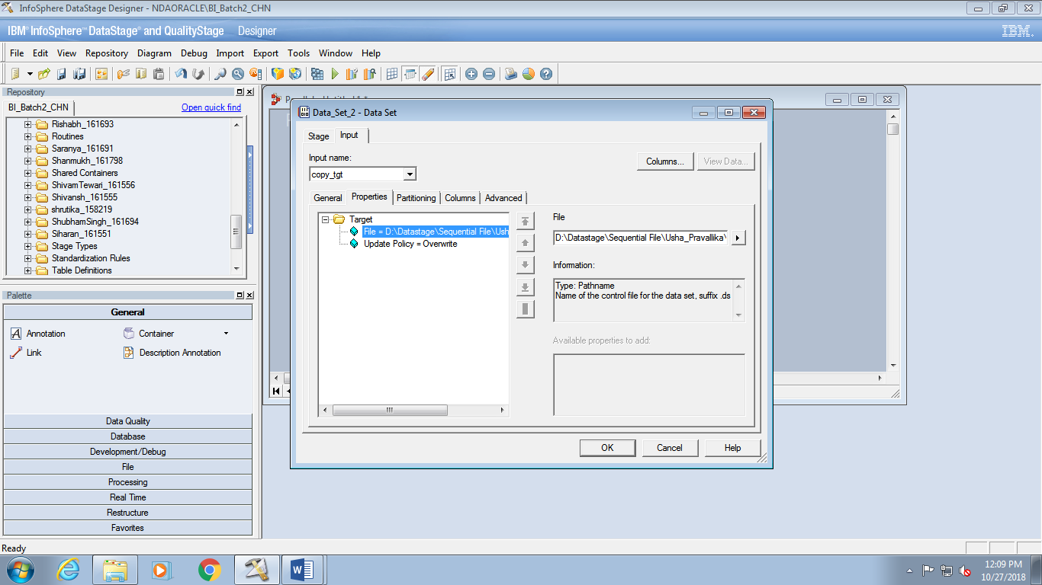

5. Open the source stage and add the optional property to read the file using multiple

readers. Change the value of the property to 2. (This will insure that data is written to more than one partition.)

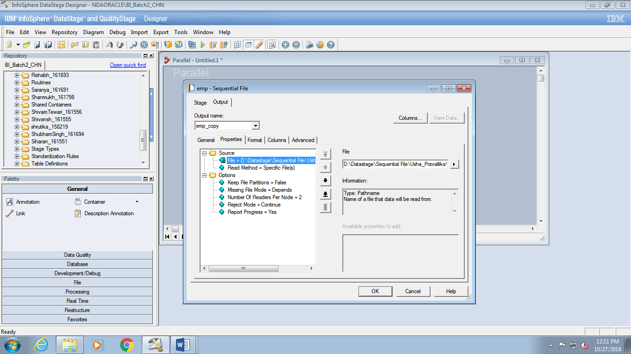

6. Check, and if necessary complete, the Copy stage columns mapping.

7. Compile your job.

8. Run your job. Check the Director log for errors.

***View a dataset***

1. In Designer click Tools > Data Set Management. Select your dataset

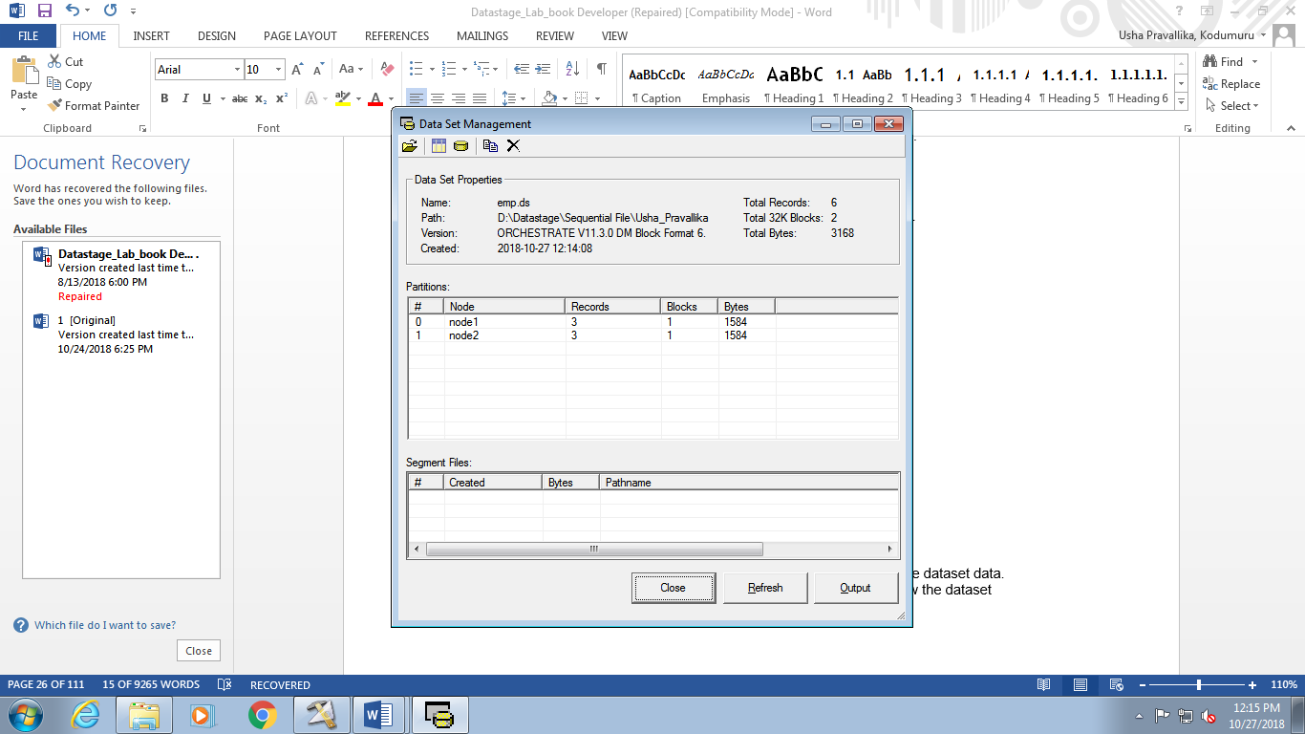

2. Click the Show Data Window icon at the top of the window to view the dataset data.

3. Click the Show Schema Window icon at the top of the window to view the dataset

schema.

***Read values meaning NULL from a sequential file***

1. Save your CreateSeqJobParam job as CreateSeqJobNULL

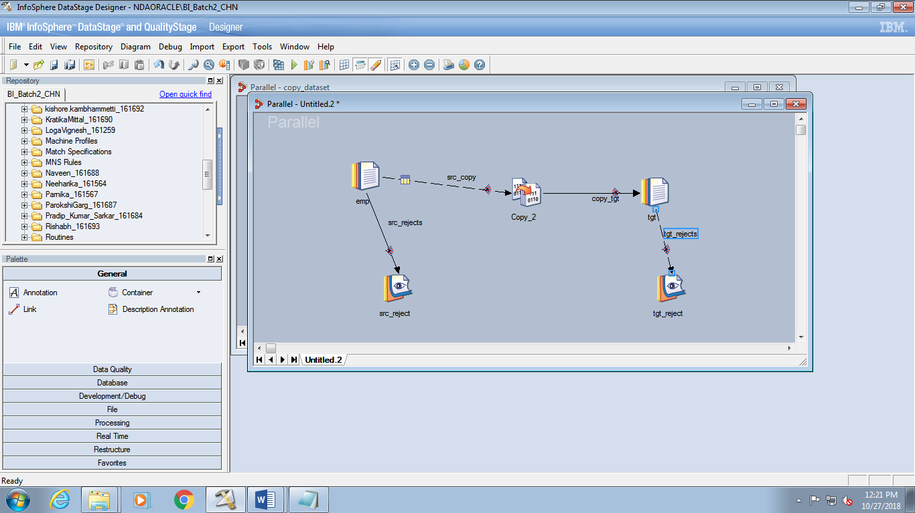

2. Open up the usha_161683.txt file in your SequentialFiles directory.

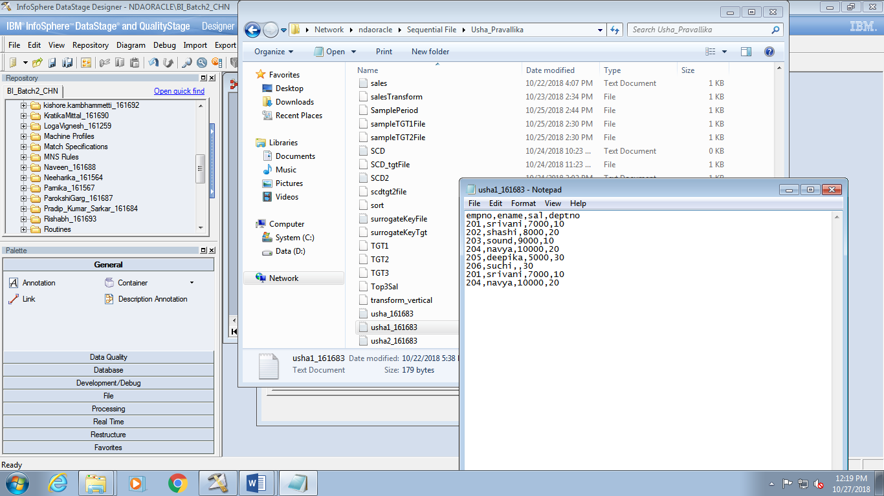

3. Notice that the last column (sal) is missing some values. To

test how to read NULLs, let’s assume that 1 in the third column means NULL and that

nothing in the last column means NULL. In the next step we will specify this.

4. Open up the source Sequential stage to the columns tab. Double-click to the left of the

Sal column to open up the Edit Column Meta Data window.

5. Change the field to nullable. Notice that the Nullable folder shows up in the Properties

window. Select this folder and then add the Null field value property. Specify a value of

1 for it.

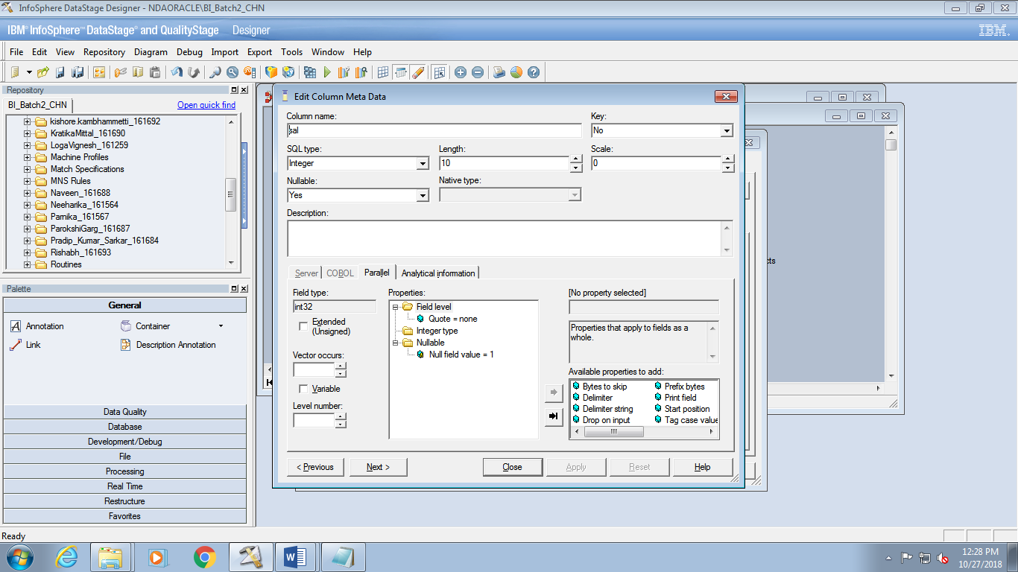

6. Click Apply

8. On the Propeties tab, select the Selling_Group_Mapping_Nulls.txt file to read.

9. Click the View Data button. Notice that values that are interpreted by DataStage as

NULL show up as the word “NULL”.

10. Compile and run your job. It should abort since NULL values will be written to nonnullable

columns on your target

***Write values meaning NULL to a sequential file***

1. Save your job as CreateSeqJobHandleNULL.

2. Open up your target stage to the Columns tab. Specify that the Special_Handling_Code

column and the Distribution_Channel_Description column are nullable.

3. Compile and run your job. What happens?

4. In this case, the job doesn’t abort, since NULL values aren’t being written to a nonnullable

column. But the rows with NULL values get rejected because the NULL values

“aren’t being handled.” Notice that they are written to the Peek stage, where you can

view them. 5. Now, let’s handle the NULL values. That is, we will specify values to be written to the

target file that represent NULLs. For the Special_Handling_Code column we will

specify a value of -99999. For the Distribution_Channel_Description column we will

specify a value of “UNKNOWN”.

6. Open up the target stage and specify these values. The procedure is the same as when the

Sequential stage is used as a source.

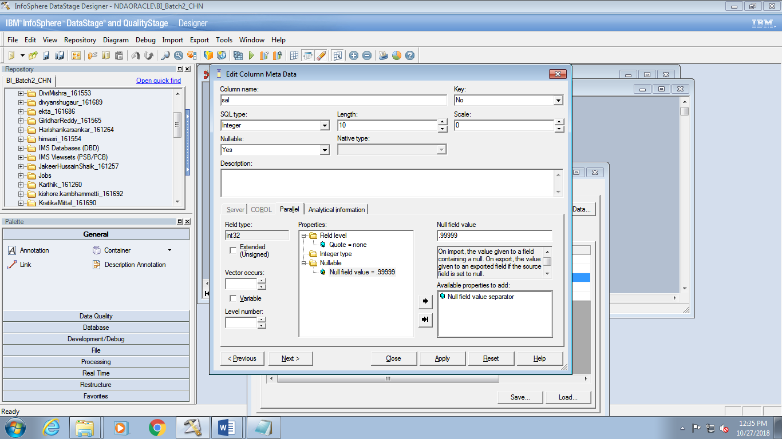

7. Compile and run your job. View the job log. You should get no errors or warnings or

rejects.

8. Verify the results by viewing your target file on the DataStage Server. (Note: if you

view the data in DataStage, all you will see is the word “NULL”, not the actual value that

means NULL.)

**LAB:4**

***Lookup Address***

1. Open a new Parallel job and save it under the name LookupWarehouseItem. Add the

stages and links and name them as shown

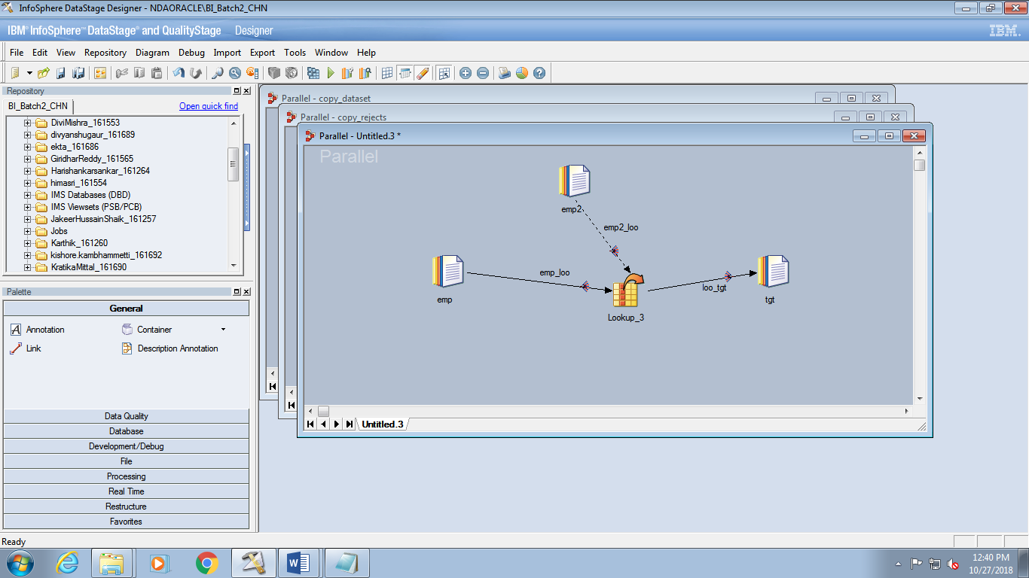

1. Import the Table Definition for the Warehouse.txt sequential file to your ushapravallika_161683>Metadata folder. Use the types shown below. (Otherwise, you will get errors when your job reads the file.)
2. 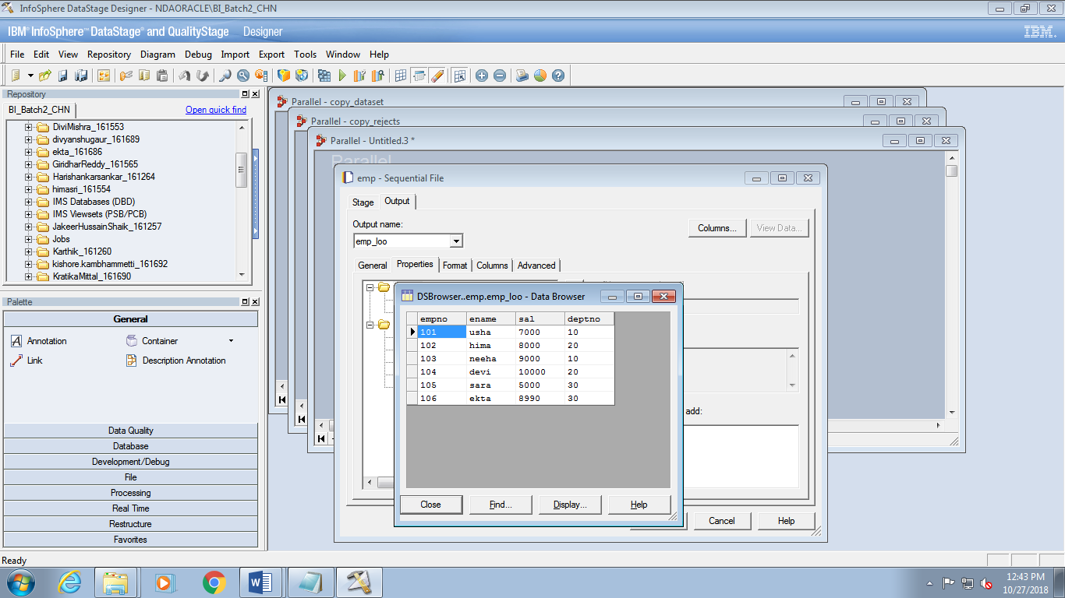

3. In the Warehouse Sequential File stage extract data from the emp.txt file. Be sure you can view the data.

4. In the Items Sequential File stage extract data from the Items.txt file. Import the Table

Definition. 5. In the Items Sequential File stage, on the Format tab, change the Quote character to the

single quote (‘). This is because some of the data contains double quotes as part of the data.

6. Open the Lookup stage. Map the Item field in the top left pane to the lookup Item key field in the bottom left pane by dragging the one to the other.

7. Drag all the emp columns to the target link.

8. Drag the Description field in the lower left pane to target link placing it just below the Item field. Change its name to hiredate.

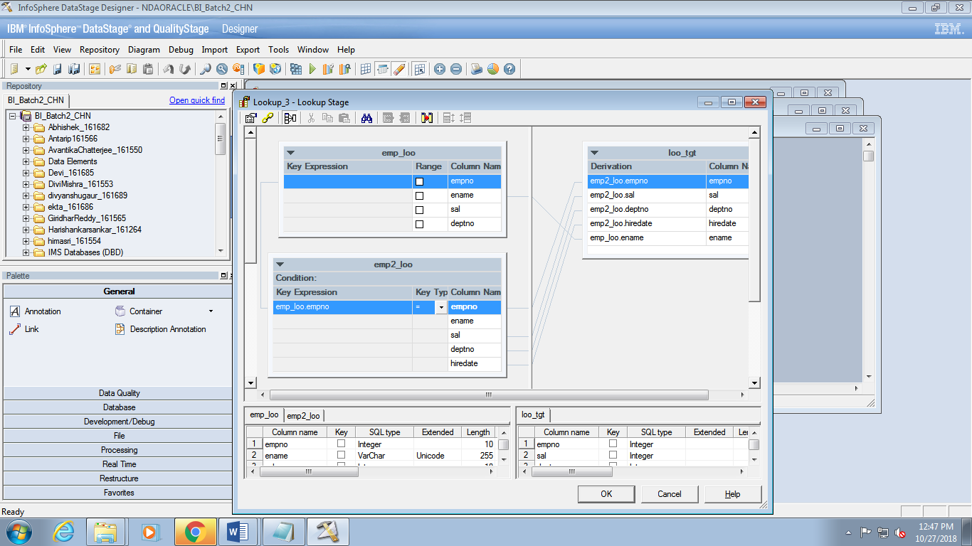

9. Edit your target Sequential stage as needed.

10. Compile and run. Examine the job log. Your job probably failed. Try to determine why it failed

***Handle lookup failures***

1. Save your job as combineLookup.

2. Open up Lookup stage. Click the constraints icon (top, second from left). When the lookup fails, specify that the job is to continue.

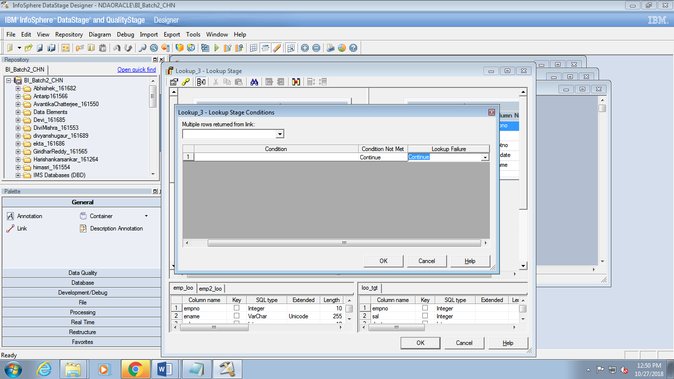

3. Compile and run. Examine the log. You should not get any fatal errors this time.

4. View the data. Do you find any rows in the target file in which the lookup failed?

(These would be rows with missing item descriptions.) What happened to these rows?

This difficult question will be answered in the next task.

5. By default, when a there is a lookup failure with Continue, DataStage outputs NULLs to the lookup columns. Since these columns are not nullable, these rows get rejected.

6. Open up the Lookup stage. Make both the Description column on the left side and the ItemDescription column on the right side nullable.

7. Open up the target sequential stage. Replace NULLs by the string “NOMATCH”.

8. Compile and run.

9. View the data in the target Sequential File stage. Notice the NULL values.

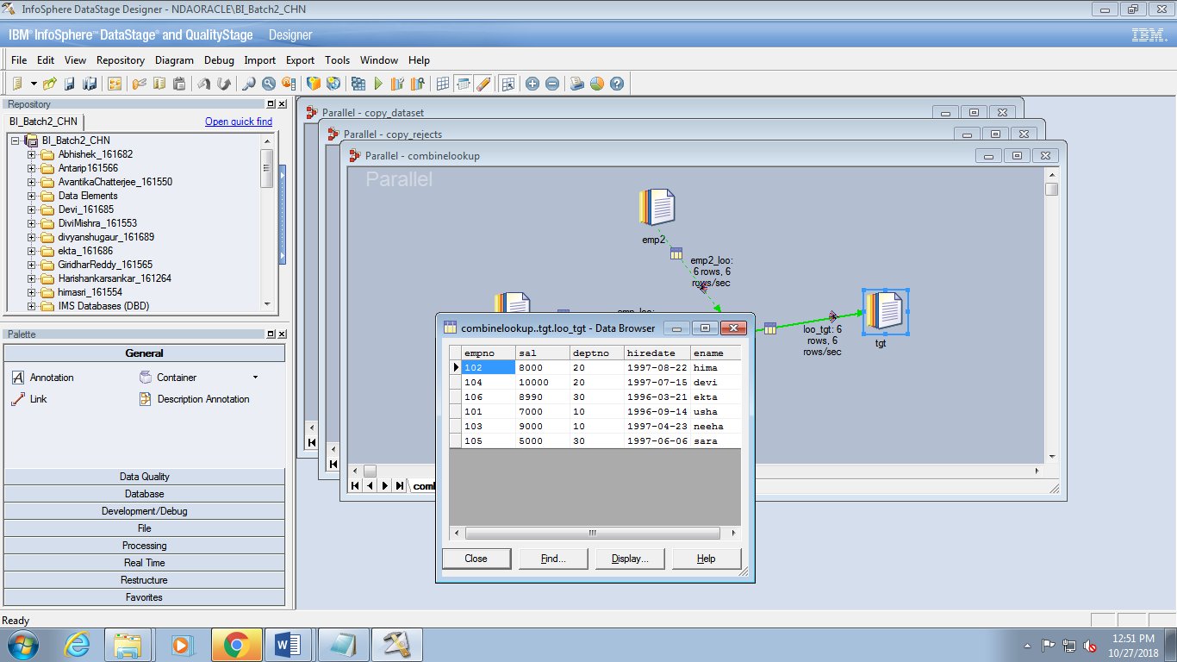

***Add a Reject link***

1. Save your job as combinelookupReject.

2. Open up Lookup stage and specify that Lookup Failures are to be rejected.

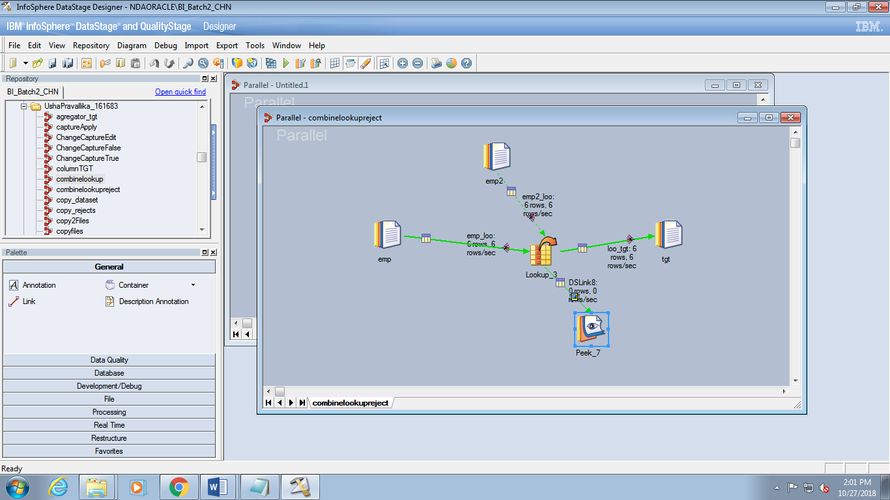

4. Compile and run. Examine the Peeks in the job log to see what rows were lookup

failures.

1. Examine the job log. Notice in the Peek messages that a number of rows were rejected.

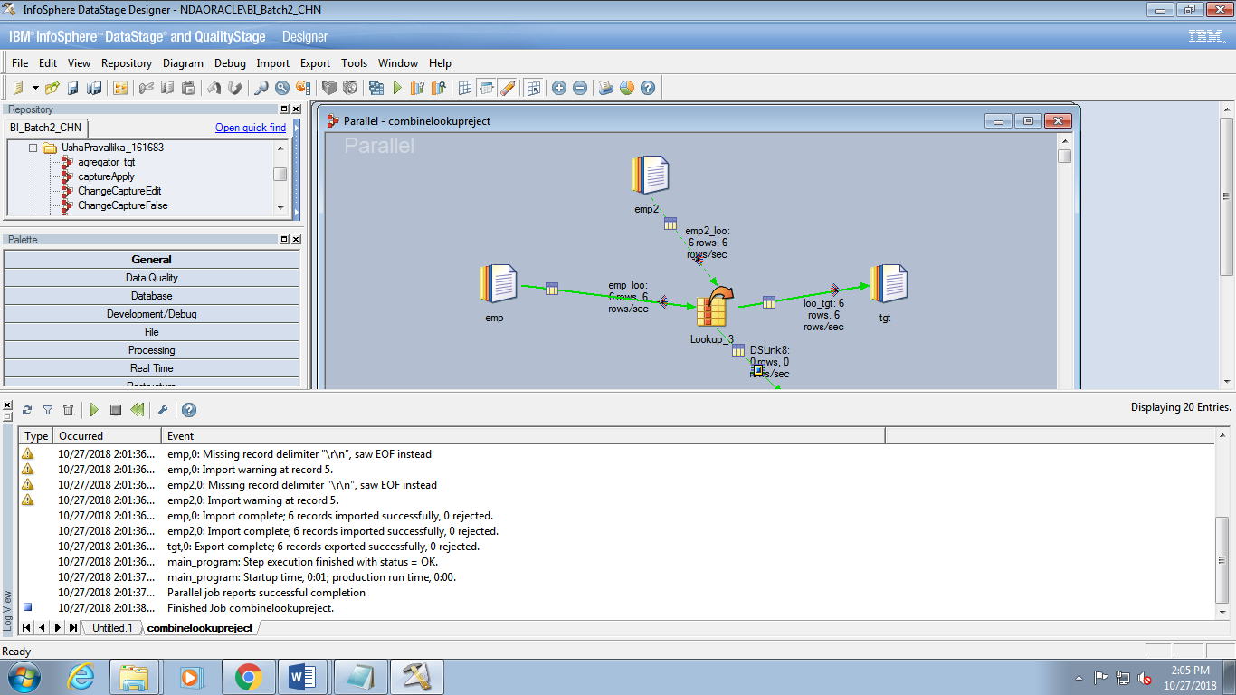

***Use Join stage***

1. Save job as combineJoin.

2. Replace the Lookup stage by the Join stage.

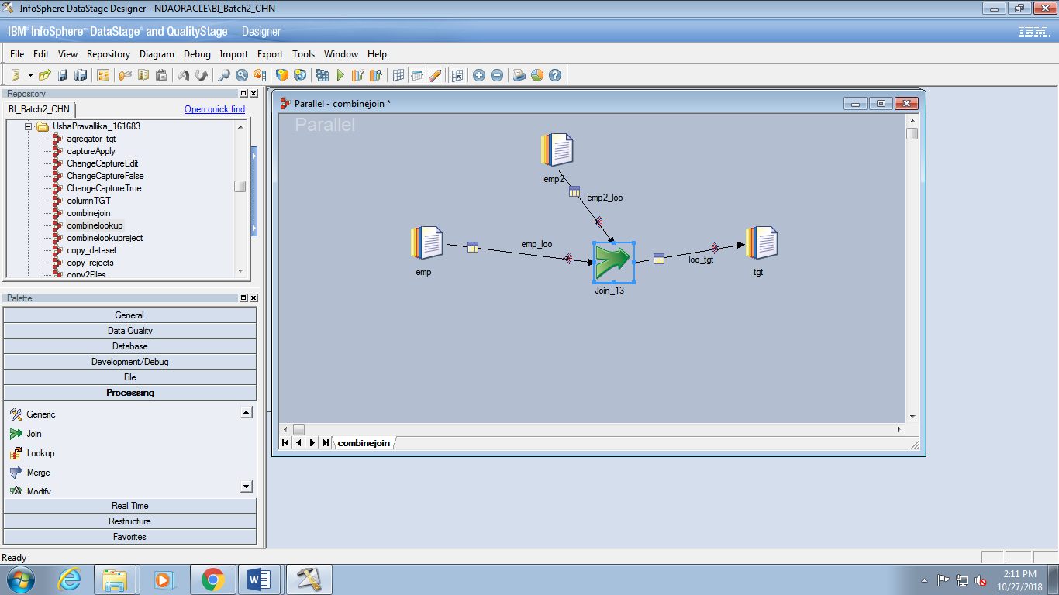

3. Join by Item in a case sensitive manner. Perform an inner join.

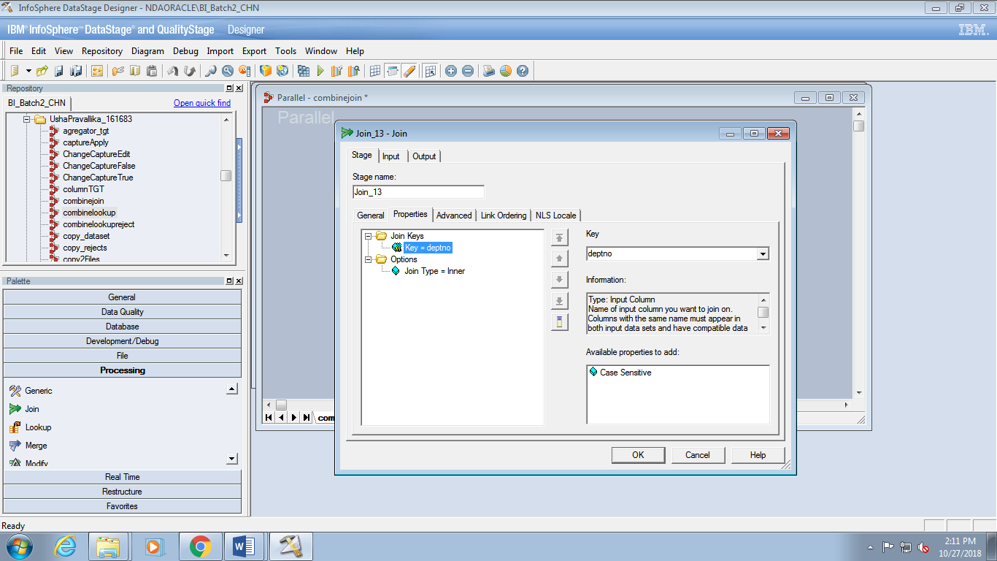

4. Click the Link Ordering tab. Make Items the Left link.

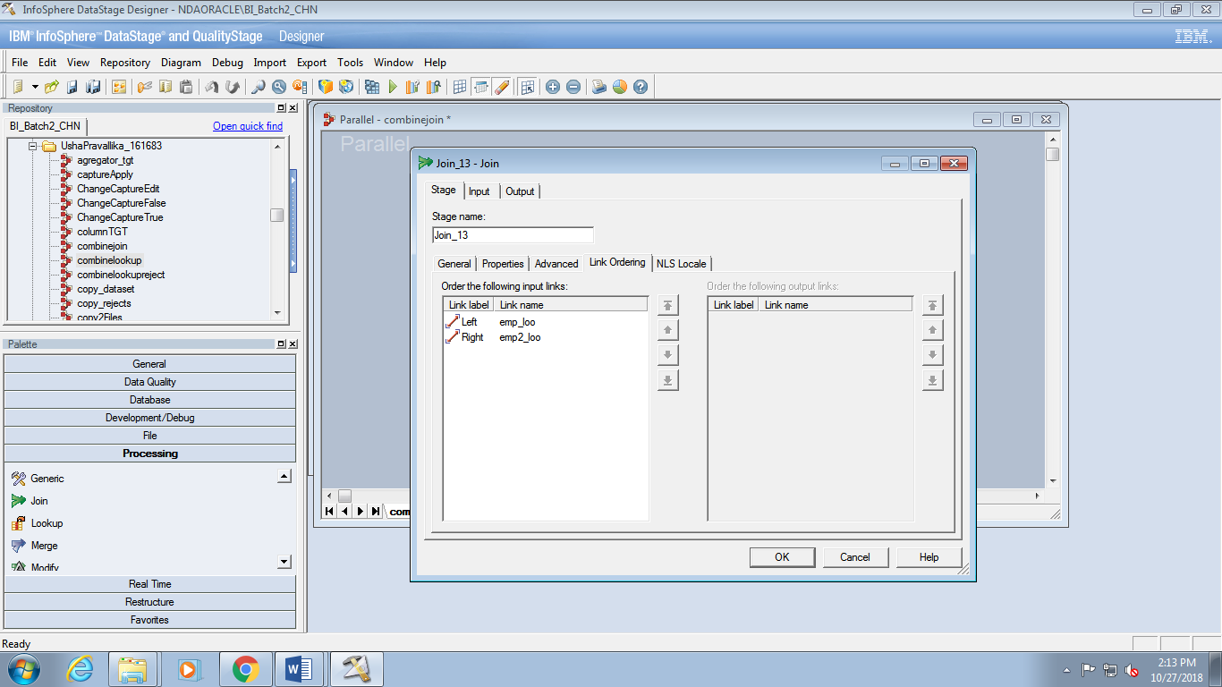

5. Check the Output>Mappings tab to make sure everything is mapped correctly.

6. Compile and run. Verify the results and verify that the number of records written to the

target sequential file is the same for the Lookup job. You can verify this by examining

the performance statistics or by seeing how many records are exported by the

stage in the job log

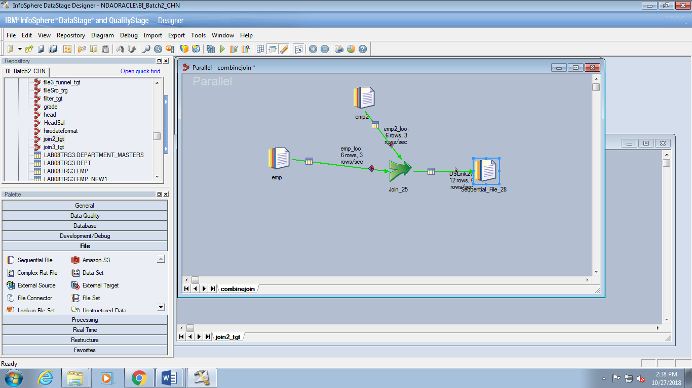

7. Recompile and run your job after selecting Right Outer Join as the join type. View the

data. You should see NULLs in the eight no-matches.

***Use Merge stage***

1. In this task, we will see if the Merge stage can be used in place of the Join stage. We will

see that it cannot be successfully used.

2. Save your job as empmerge. Replace the Join stage by the Merge

stage.

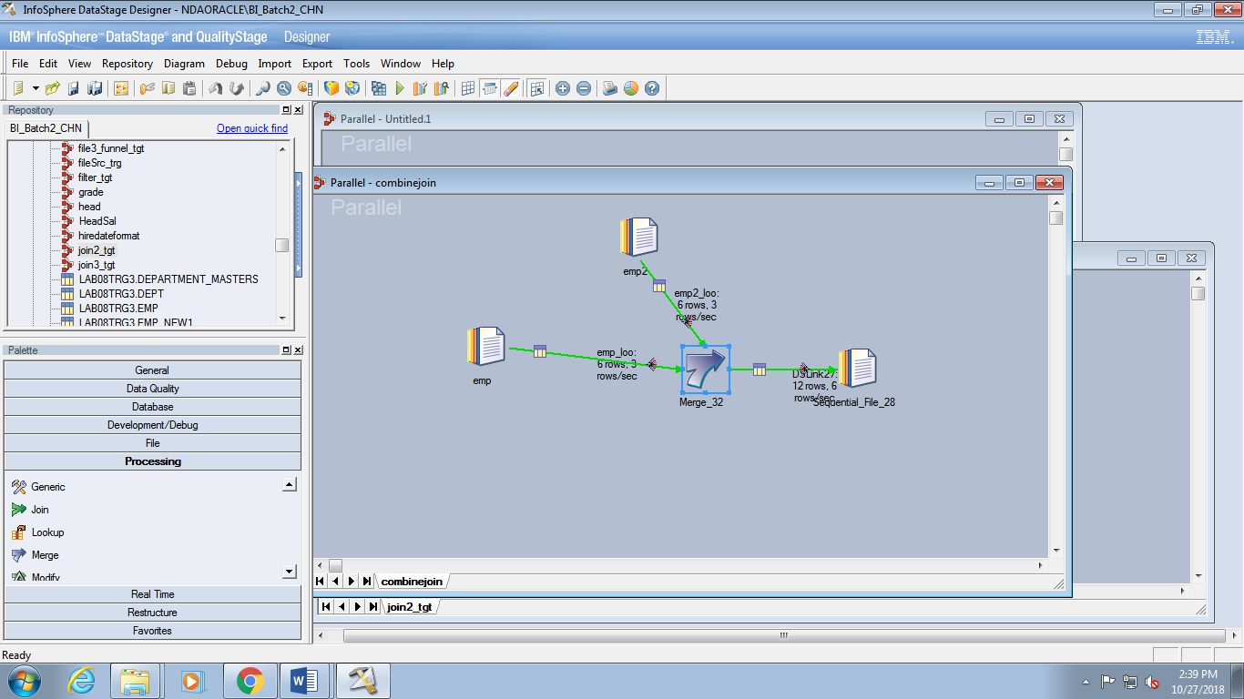

3. In the Merge stage, specify that data is to merged, with case sensitivity, by the key (Item).

Assume that the data is sorted in ascending order. Also specify that unmatched records

From emp (the Master) are to be dropped.

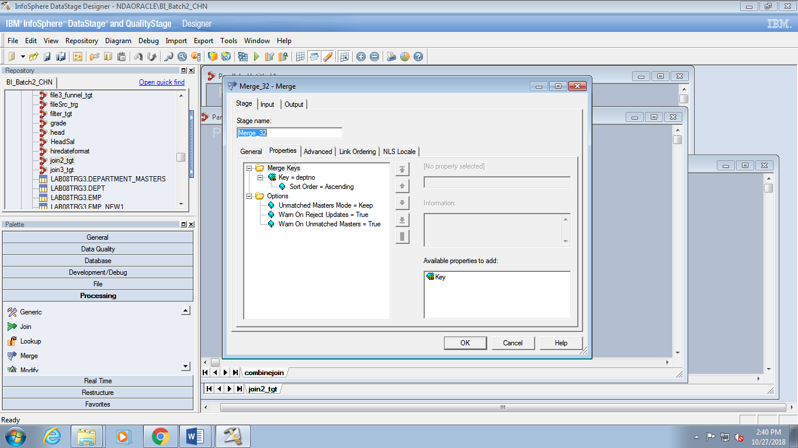

4. Insure that the merge link is the Master link.

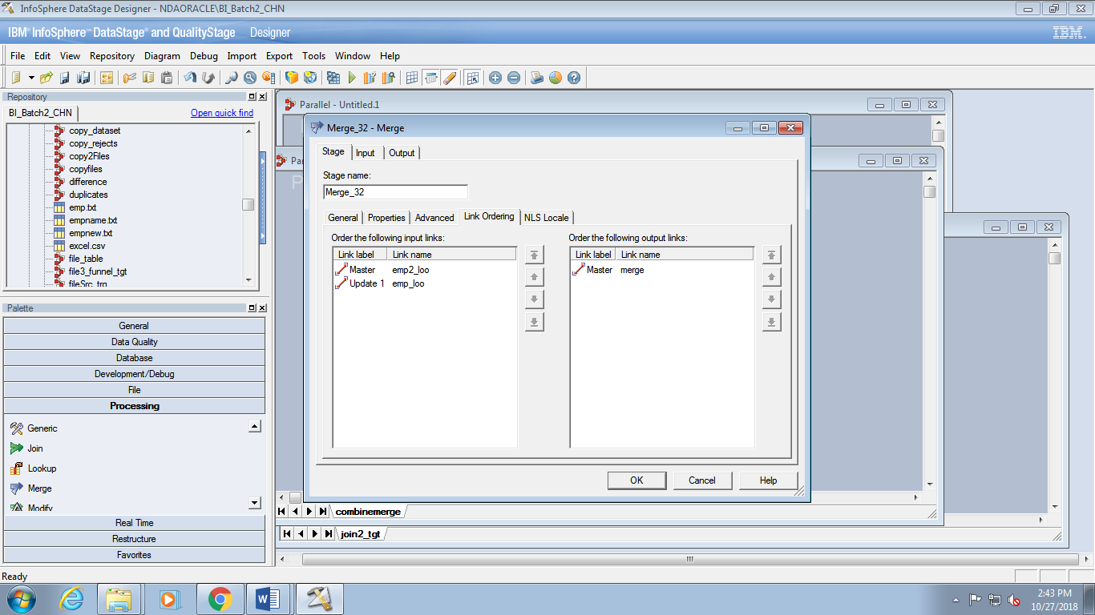

5. Map input columns to the appropriate output columns.

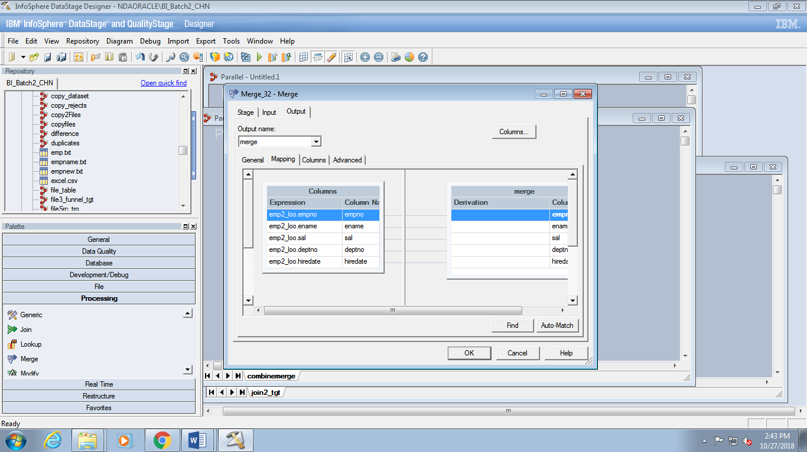

6. Compile and run. View the data.

7. Examine the performance statistics and/or job log to determine how many records were written to the target sequential file.

8. Notice that over 80 fewer rows are written to the target sequential file. Why? Examine the job log. Notice that a bunch of records from the Warehouse.txt file have been dropped because they have duplicate key values

9. The moral here is that you cannot use the Merge stage if your Master source has duplicates. None of the duplicate records will match with update records.

10. Recall that another requirement of the Merge stage (and Join stage) is that the data is hashed and sorted by the key. We did not do this explicitly, so why didn’t our job fail?

Let’s examine the job log for clues. Open up the Score message. Notice that sorts (tsort operators to be precise) have been added by DataStage

***Range lookups***

***Task: Design a job with a reference link range lookup***

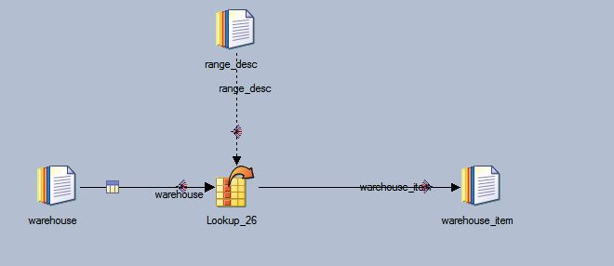

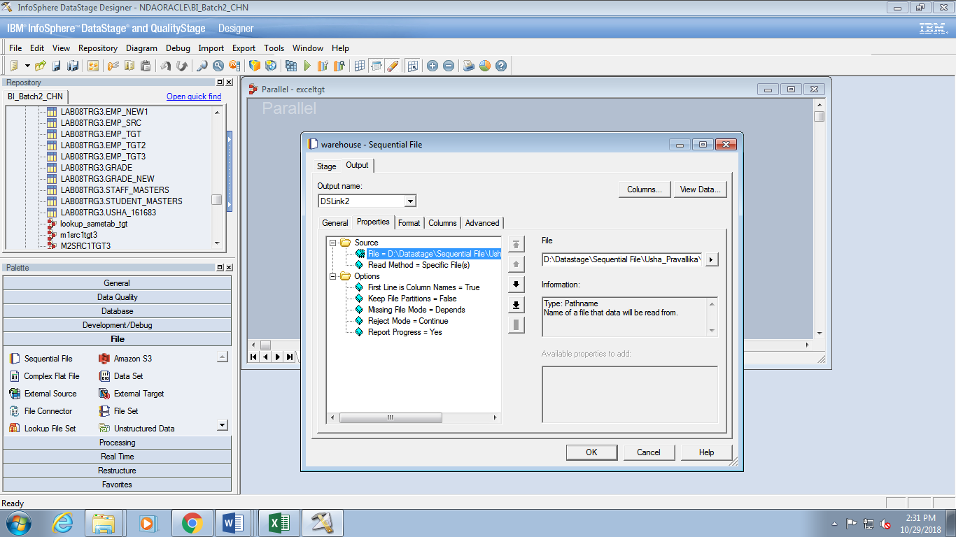

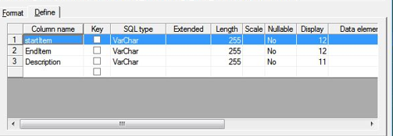

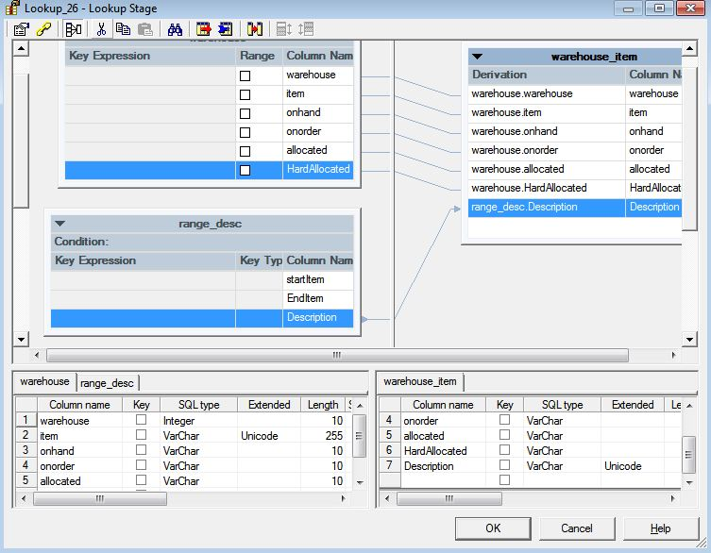

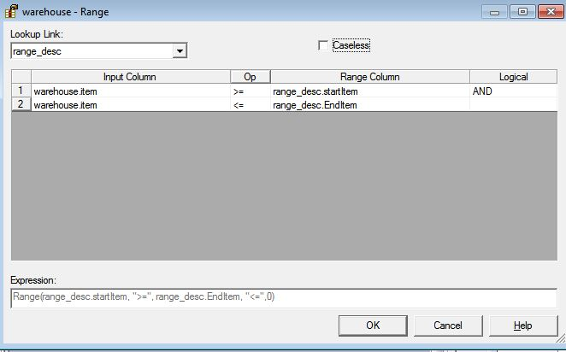

***Task: Design a job with a stream range lookup***

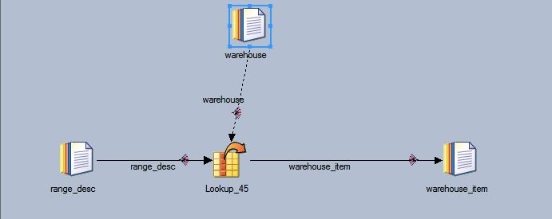

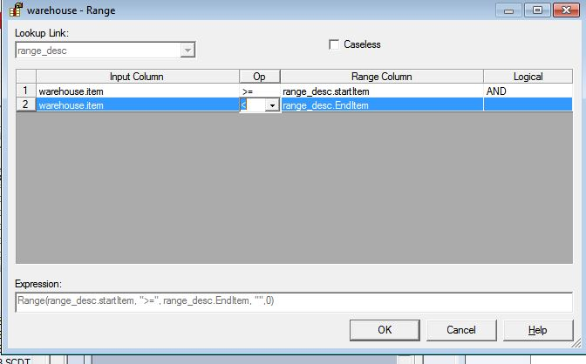

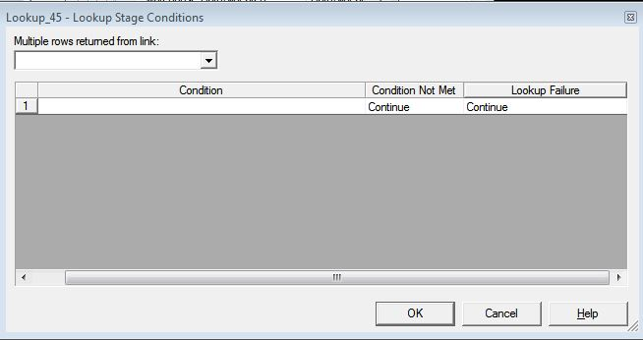

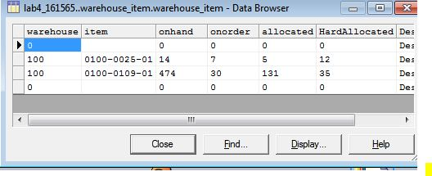

***Combining data using the Funnel Stage***

***Task: Build a job with a Funnel stage***

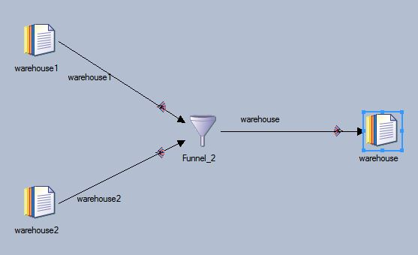

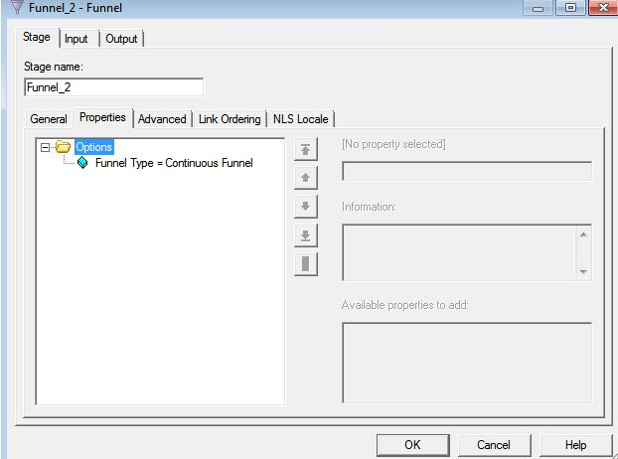

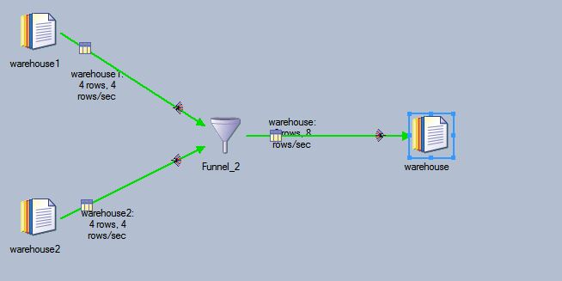

Lab 05: Sorting and Aggregating Data

***Task: Create the job design***

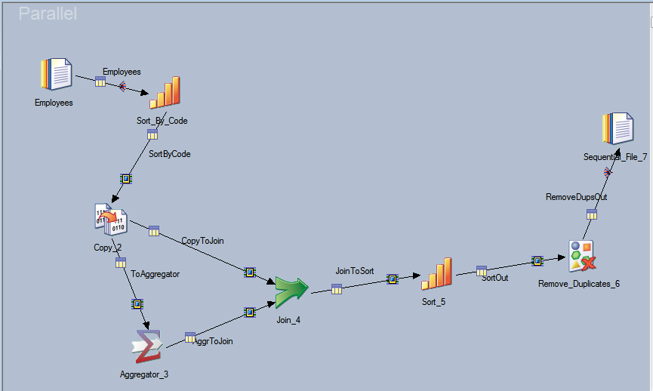

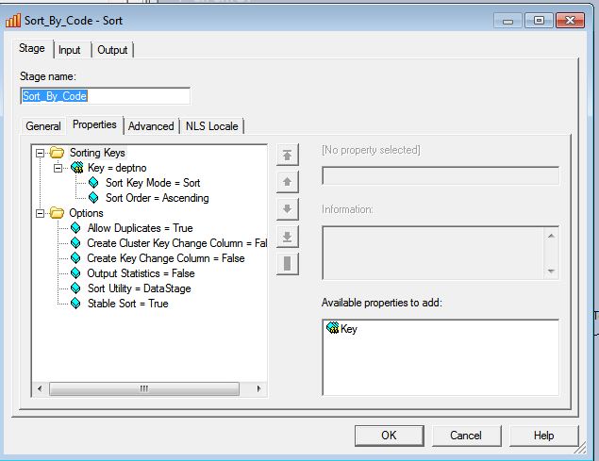

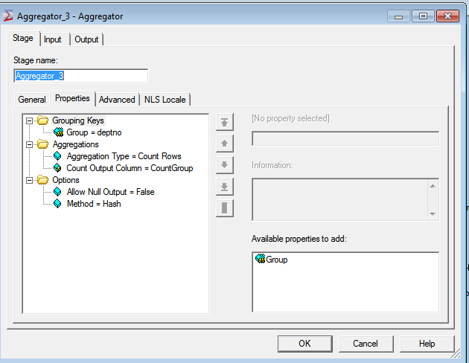

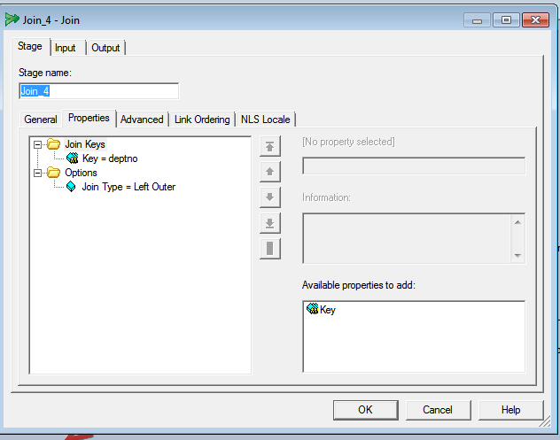

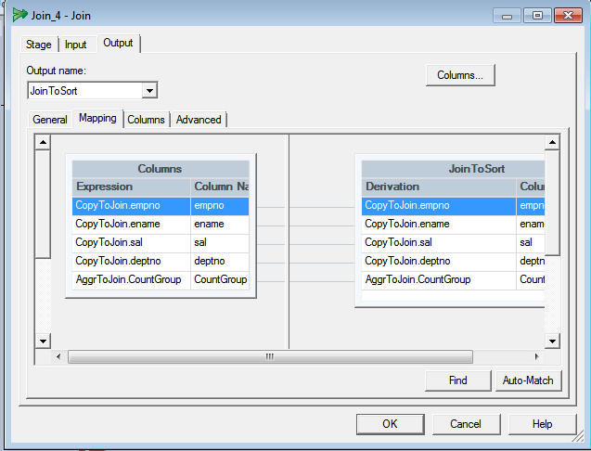

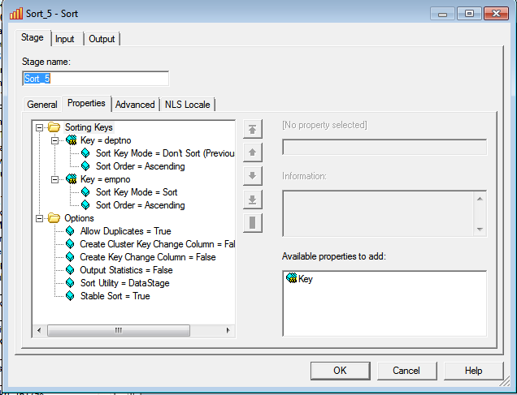

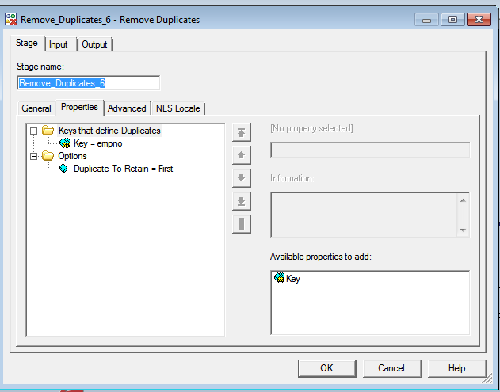

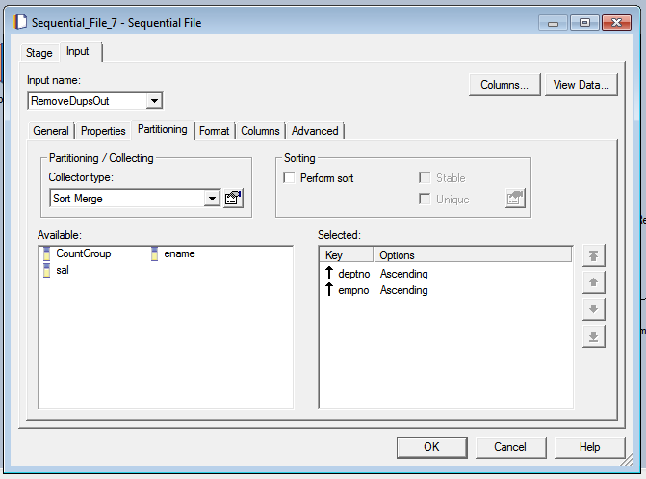

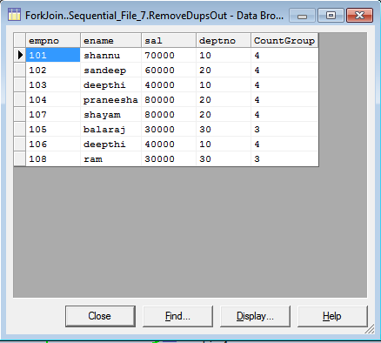

Lab 06: Transforming Data

***Task: Create a parameter set***

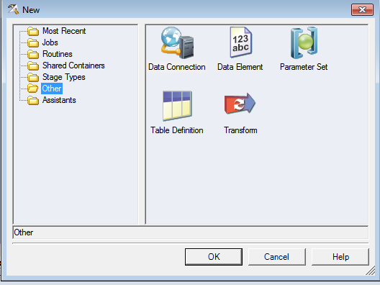

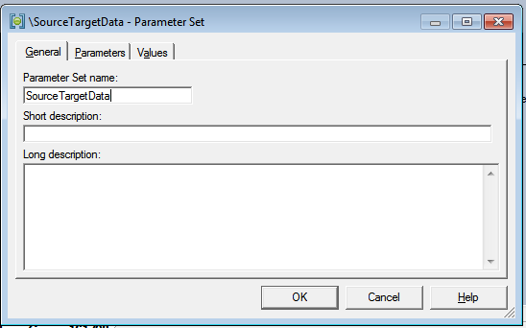

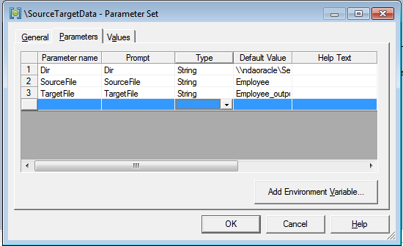

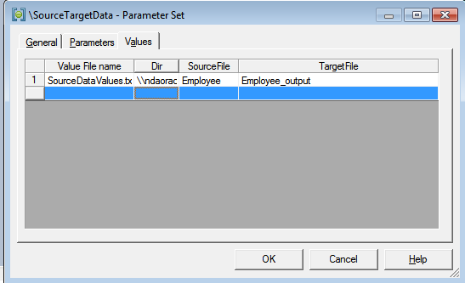

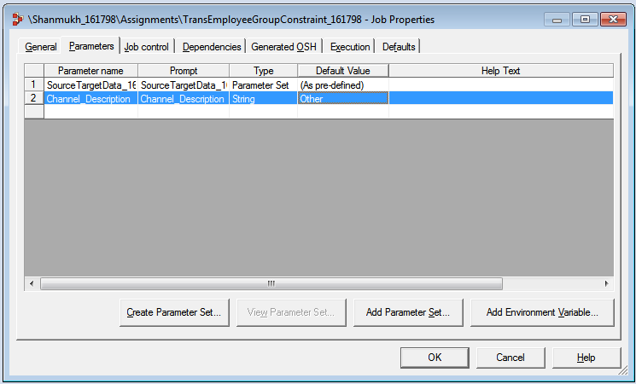

***Task: Add a Transformer stage to a job***

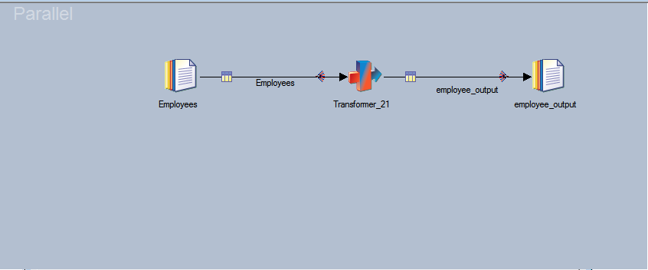

***Task: Define a constraint***

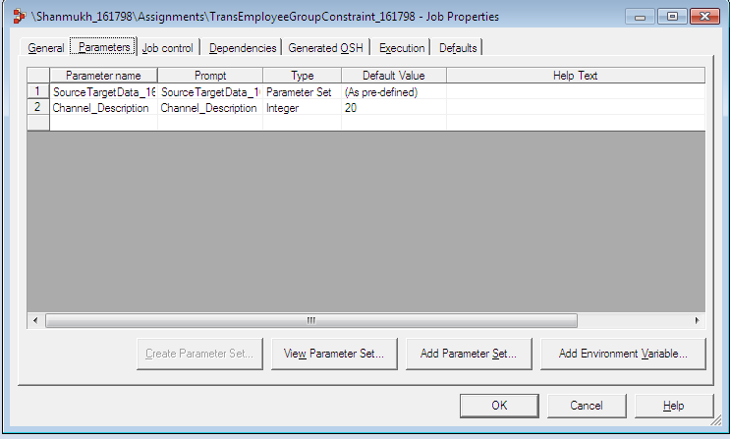

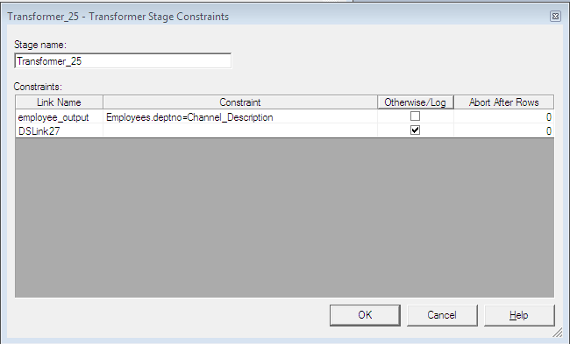

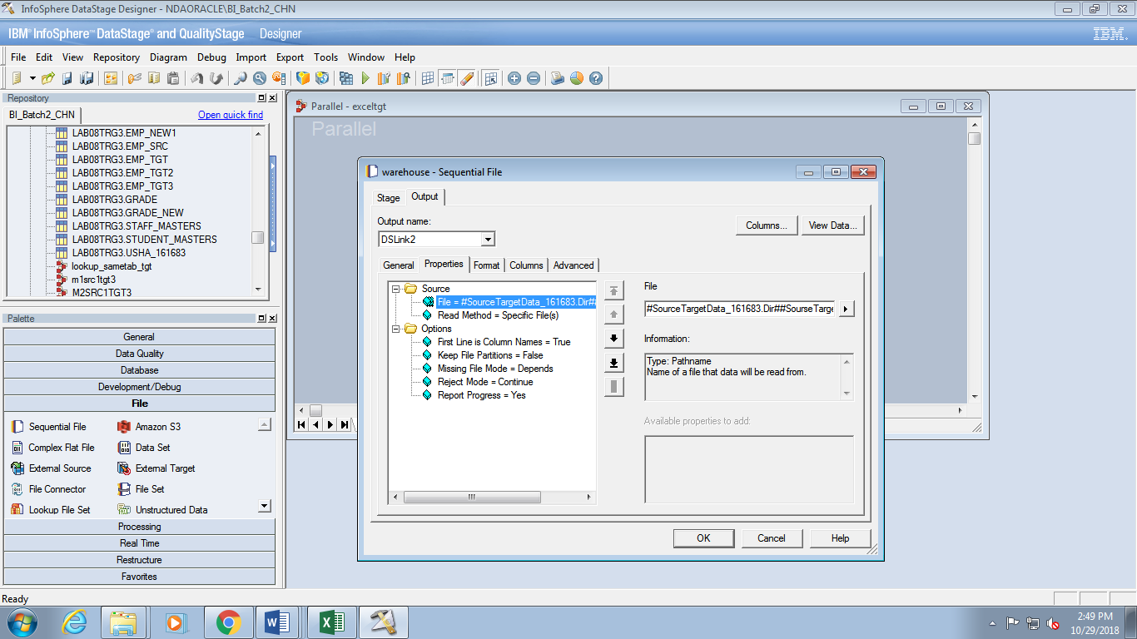



***Task: Define an Otherwise Link***

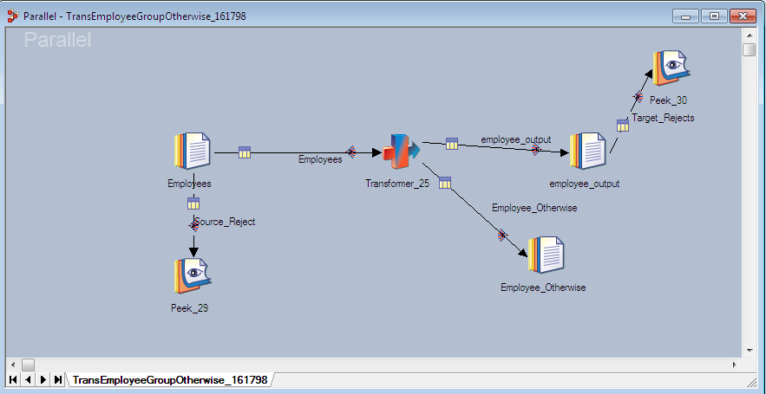

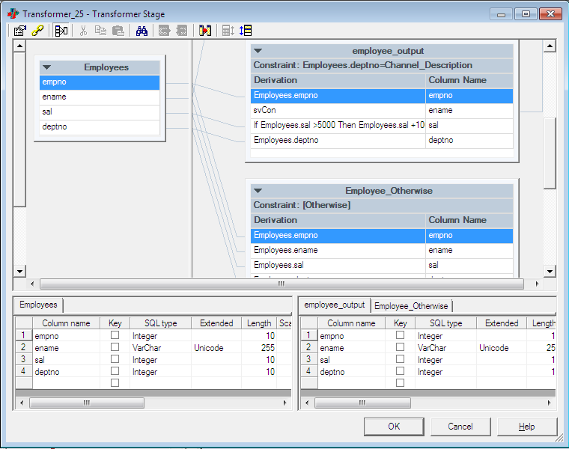

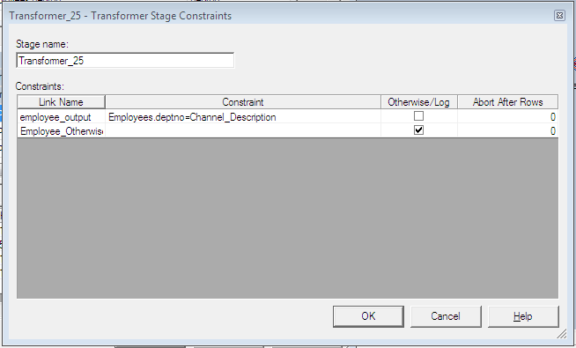

***Task: Define derivations***

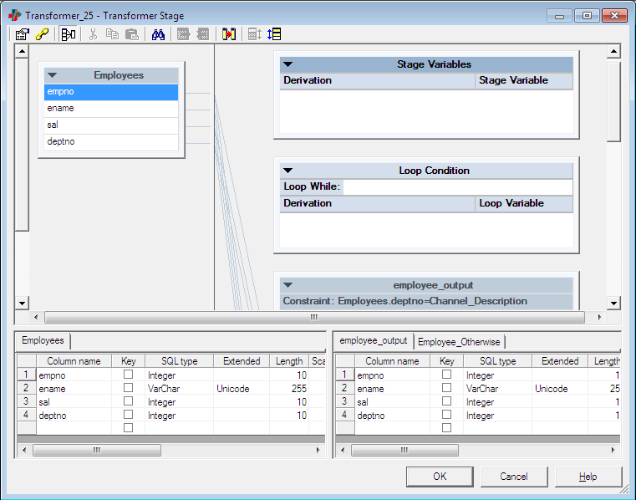

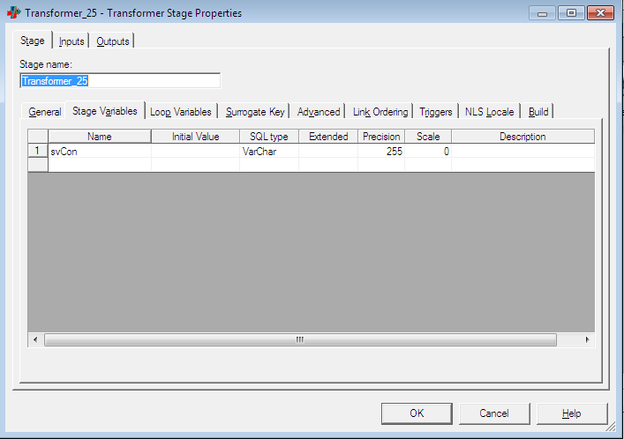

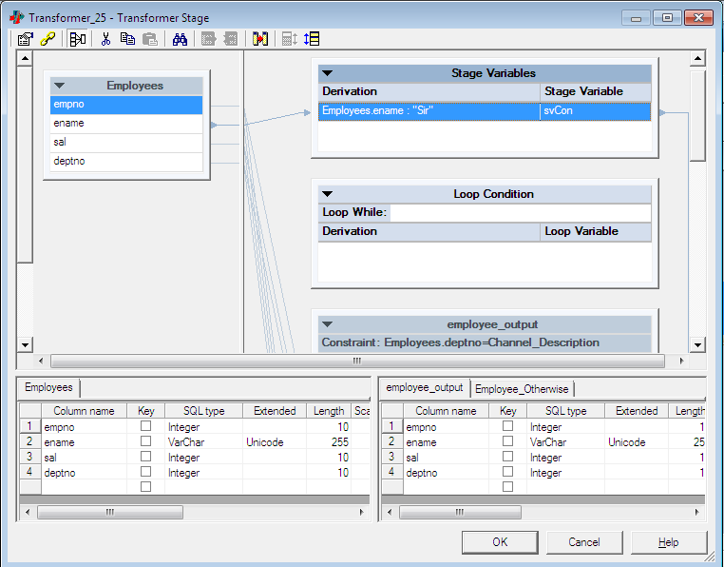

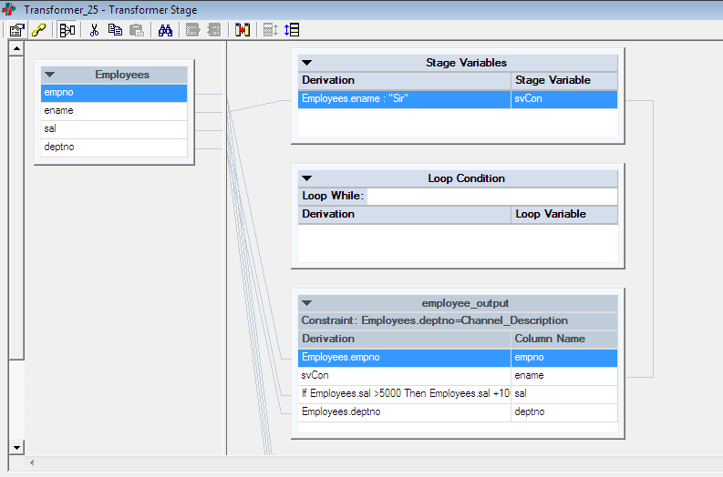

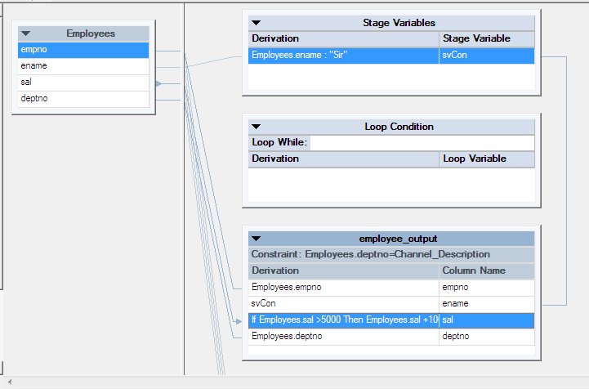

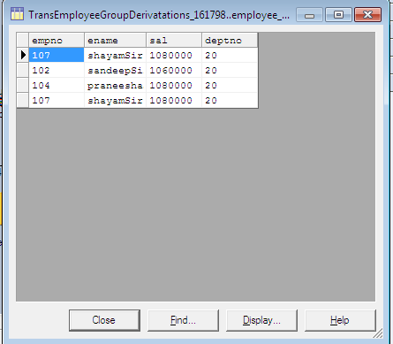

Lab 08: Platform Architecture

***Task: Partitioning and collecting***

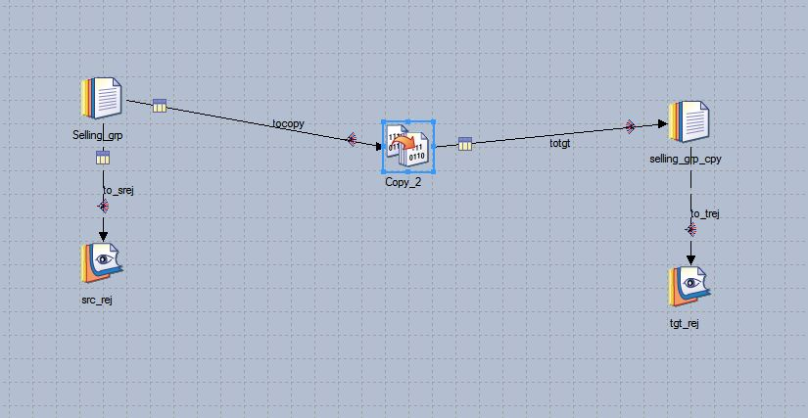

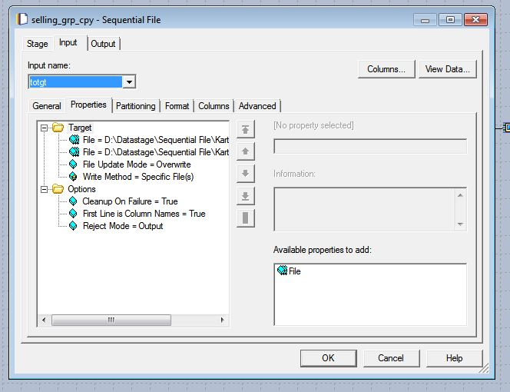

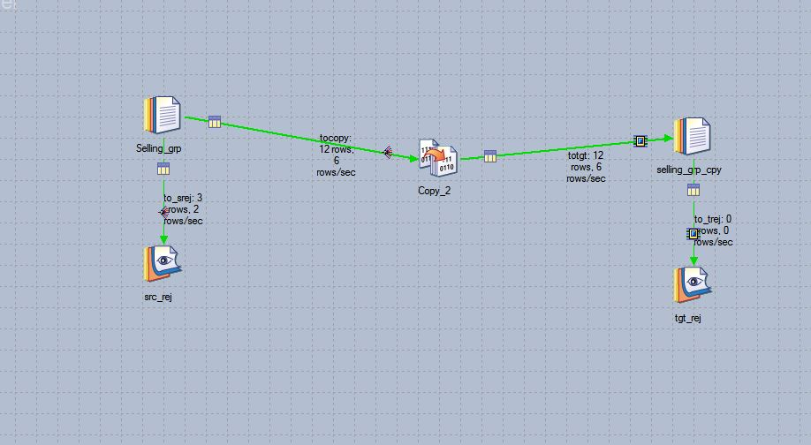

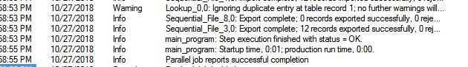

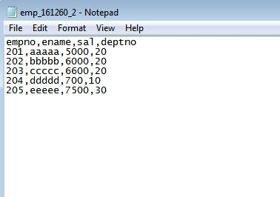

Lab 11: Job Control

In this exercise, you create a single job sequence that executes three jobs.

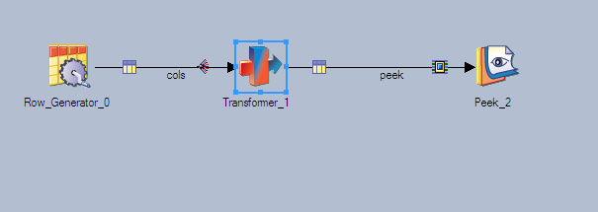

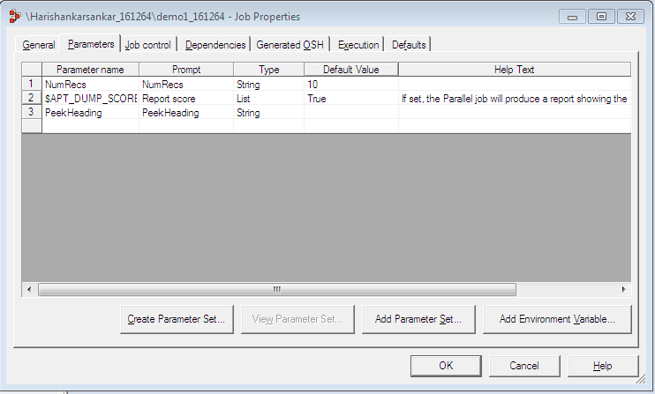

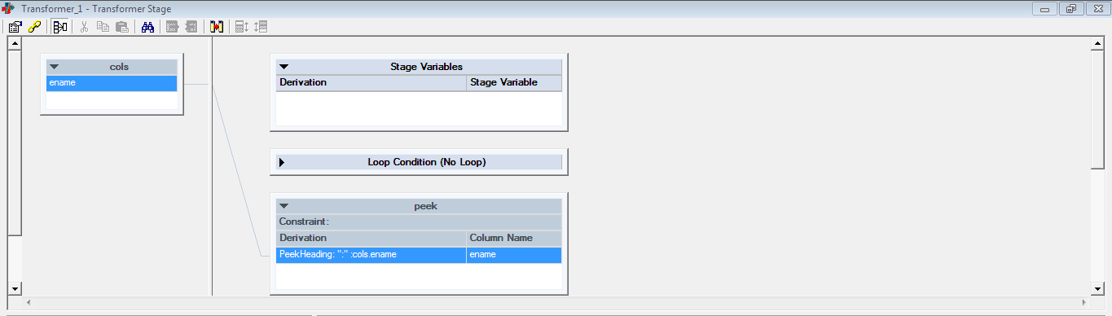

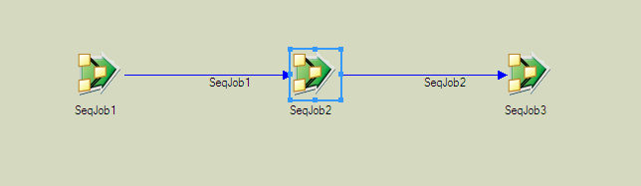

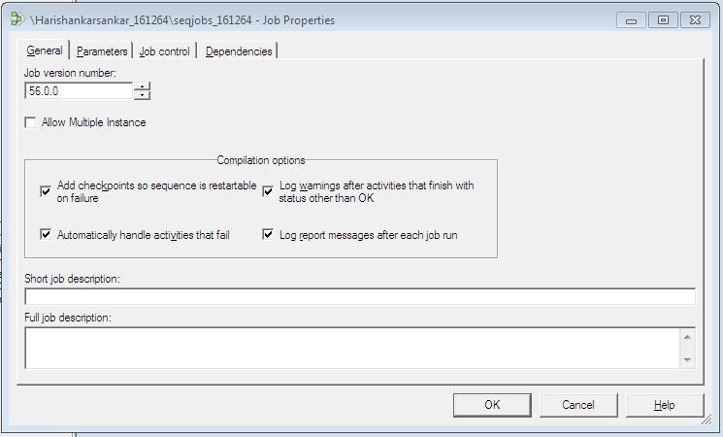

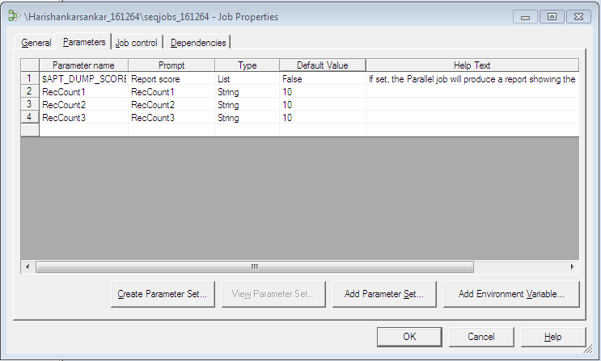

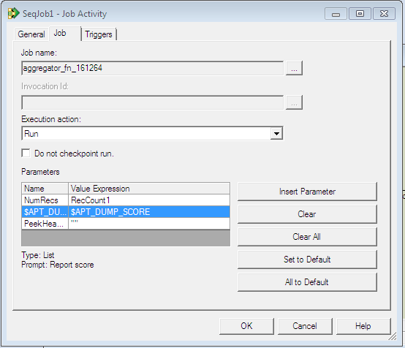

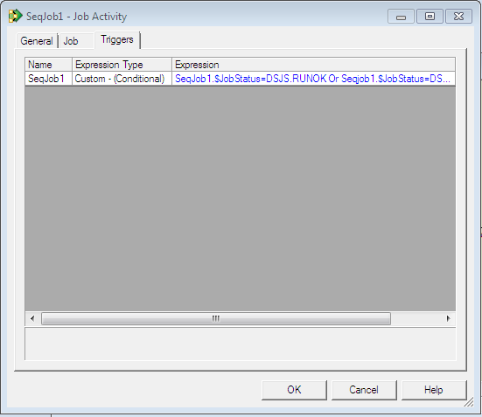

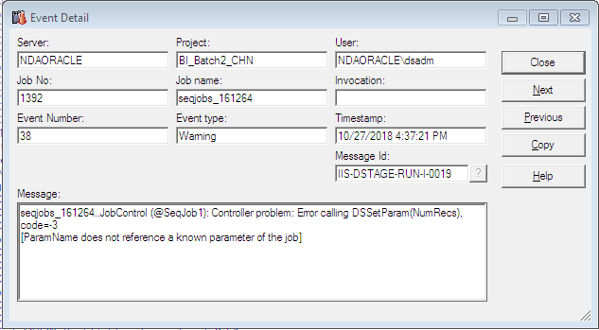

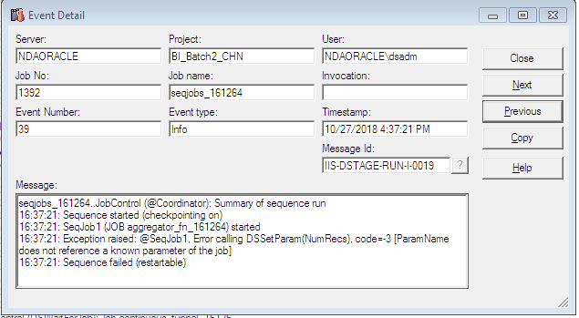

***Task: Add a user variable***

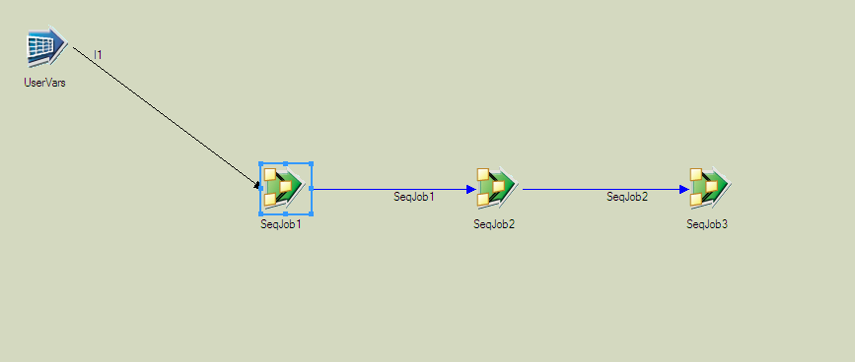

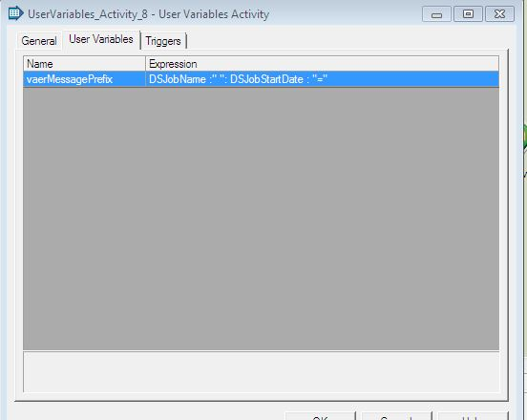

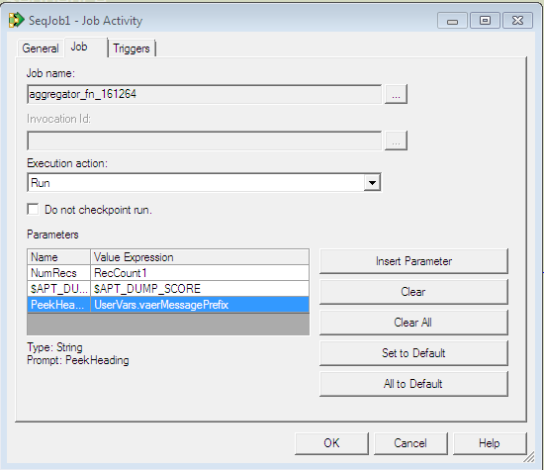

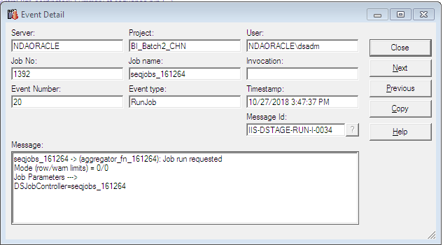

***Task: Add a Wait for File stage***

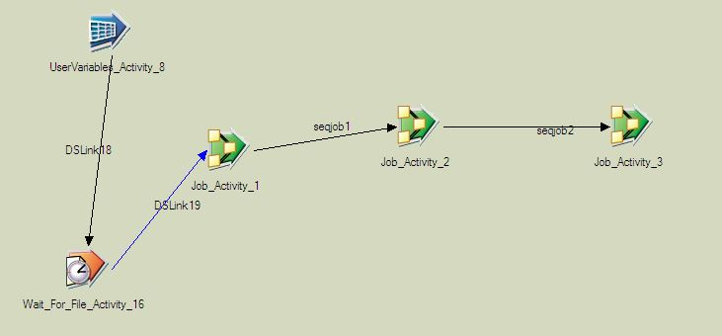

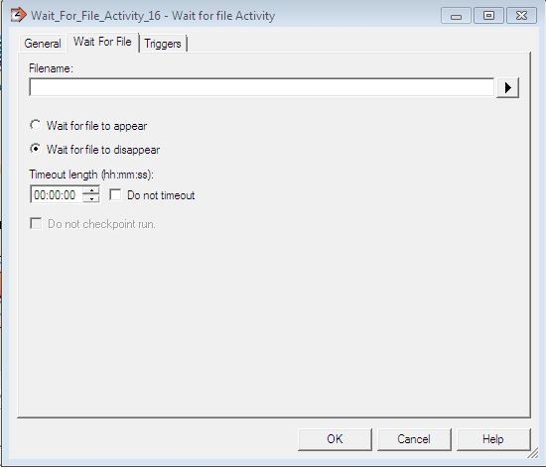



***Task: Add exception handling***

